
BREATHEWELL-LUNG DISEASE DETECTION AND CARE ASSISTANCE

Zulqarnain Hassan (SP21379)
Muhammad Younus(SP21452)
Mumtaz Ali(SP21386)

Supervised By
Dr. Maryam Imtiaz Malik

Submitted for the partial Fulfillment of BS Software Engineering degree to the Faculty of Engineering and Computing
NATIONAL UNIVERSITY OF MODERN LANGUAGES ISLAMABAD
December, 2025

ABSTRACT
Respiratory are widespread and often go undiagnosed due to the lack of accessible early detection tools. Early symptoms of these conditions are often subtle and easily overlooked, leading to delayed diagnosis and treatment. Limited access to specialized healthcare facilities, lack of affordable screening tools, and low public awareness contribute to the underdiagnosis and progression of respiratory illnesses. Many individuals find it difficult to monitor their lung health, identify worsening symptoms, and receive care recommendations without visiting a healthcare provider.
To address this challenge, this project introduces BreatheWell an application designed to detect, monitor, and manage respiratory conditions, specifically asthma, COPD, bronchitis, and pneumonia. With this application users can report symptoms to upload and record breathing and cough sounds, which are analyzed using machine learning to identify patterns such as wheezing, dry or wet coughs, and irregular breathing. By combining audio analysis with symptom input, BreatheWell delivers accurate assessments and helps users understand their respiratory status. Additionally, it provides features for tracking symptoms over time, generating visual timelines and detailed health reports. It also offers personalized care plans, home remedy suggestions, and alerts for worsening conditions, while integrating real-time air quality data to warn users of environmental risks. Moreover, an AI chatbot provides real-time support, and users can maintain a comprehensive medical history with downloadable reports for ongoing respiratory health management.
BreatheWell employs a modern full-stack architecture to deliver its AI-powered respiratory health solutions. The frontend is built with Reac.js to create a dynamic and responsive user interface. Backend services are powered by Python or Node.js, chosen for its extensive libraries in data science and machine learning, with frameworks such as Framework of python (Django or Flask) managing API development and server-side logic. utilizing PostgreSQL and MongoDB for efficient data management and firebase for authentication and real-time user-system communication.

CERTIFICATE
Date:_____________
Final Approval
It is certified that the project report titled BreatheWell-lung disease detection and care assistance submitted by Zulqarnain Hassan, Muhammad Younus and Mumtaz Ali for the partial fulfillment of the requirement of “Bachelor’s Degree in Software Engineering” is approved.
COMMITTEE
Dr. Muhammad Noman Malik
DEAN FEC Signature: ___________________

Dr. Sumaira Nazir
HOD Software Engineering Signature: ___________________

Dr. Naveed Ahmed
Head Project Committee Signature: ___________________

Dr. Maryam Imtiaz Malik
Supervisor Signature: ____________________

DECLARATION

We hereby declare that our dissertation is entirely our work and genuine / original.
We understand that in case of discovery of any PLAGIARISM at any stage, our group will be assigned an F (FAIL) grade and it may result in withdrawal of our Bachelor’s degree.
Group Members Signature
1. Zulqarnain Hassan ___________________

2. Muhammad Younus ___________________

3. Mumtaz Ali ___________________

TABLE OF CONTENTS
CHAPTER PAGE
CHEPTER: 1 INTRODUCTION 13
1.1 Introduction 14
1.2 Motivation 14
1.2.1 Mild Early Symptoms and Late Diagnosis 14
1.2.2 Limited Access to Specialists 15
1.2.3 Expensive and Inconvenient Testing 15
1.2.4 Low Awareness and Poor Self-Tracking 15
1.2.5 Environmental Risks 15
1.2.6 Need for Ongoing and Personal Care 15
1.3 Problem Statement 15
1.4 Proposed System 16
1.4.1 Symptom Submission 16
1.4.2 AI-Powered Cough & Breathing Analysis 16
1.4.3 Smart Diagnosis System 16
1.4.4 Symptom Tracker & Dashboard 16
1.4.5 Personalized Care Plan 16
1.4.6 Environmental Alert System 16
1.4.7 AI Chatbot 16
1.4.8 Exercise Recommendations 17
1.5 Goals And Objectives 17
1.5.1 Goal 17
1.5.2 Objectives 17
1.6 Developed System Features 17
1.6.1 Symptom Submission 17
1.6.2 AI-Powered Cough and Breathing Analysis 17
1.6.3 Smart Diagnosis System 18
1.6.4 Symptom Tracker and Dashboard 18
1.6.5 Personalized Care Plan 18
1.6.6 Environmental Alert System 18
1.6.8 Patient History Tracking 18
1.6.9 Exercise Recommendations 18
1.6.10 Report Generation 19
1.6.11 User Authentication (Sign Up and Login) 19
1.7 Scope of the Study 19
1.8 Tools & Technology 19
1.8.1 Software 19
1.8.2 Hardware 19
1.9 Expertise of the Team Members 20
1.10 Process Model 21
1.11 Nature of the Project 22
1.12 Process Flow 22
1.13 Milestone 27
1.14 Overview 27
CHEPTER: 2 BACKGROUND AND EXISTING WORK 28
2.1 Introduction 29
2.2 Key Components of the BreatheWell System 29
2.2.1 Frontend – React 29
2.2.2 Backend 29
2.2.3 Artificial Intelligence – Machine Learning and Deep Learning 29
2.2.4 Database 30
2.3 Existing Systems 30
2.4 Limitations of Existing Systems 30
2.4.1 Ada Health 30
2.4.2 AsthmaMD 30
2.4.3 ResApp Health 31
2.4.4 Hyfe App 31
2.5 Comparison Table of Existing Systems vs. BreatheWell 31
2.6 Summary 32
CHEPTER: 3 REQUIREMENTS SPECIFICATION 33
3.1 Introduction 34
3.2 Interface Requirements 34
3.2.1 Hardware Requirements 34
3.2.2 Software Requirements 34
3.3 Functional Requirements 35
3.3.1 Signup 35
3.3.2 Login 35
3.3.3 Symptom Submission 35
3.3.4 Audio Recording/Upload 35
3.3.5 AI Audio Analysis 36
3.3.6 Smart Diagnosis 36
3.3.7 Personalized Care Plan Generation 36
3.3.8 Dashboard 37
3.3.9 Environmental Alerts 37
3.3.10 AI Chatbot Support 37
3.3.11 Patient History Tracking 37
3.3.12 Report Generation 38
3.3.13 Exercise Recommendation 38
3.3.14 Schedule Doctor appointment 38
3.3.15 See Appointment Request 38
3.4 Non-Functional Requirements 39
3.5 Use Case Diagram 39
3.6 Use Cases Description 41
3.6.1 Perform Smart Diagnosis 41
3.6.2 View History 42
3.6.3 Check Environmental Alert 42
3.6.4 Account Register 43
3.6.5 Consult AI Assistant 44
3.6.6 Generate Report 45
3.6.7 Submit Symptoms 46
3.6.8 Record Cough 47
3.6.9 View Care Plan 47
3.6.10 Schedule Doctor Appointment 48
3.6.11 Exercise Recommendation 49
3.6.12 See Appointment Request 50
3.7 Summary 50
CHEPTER: 4 SYSTEM MODELING 51
4.1 Introduction 52
4.2 System Design 52
4.2.1 Architectural Overview (Three-Tier Model) 52
4.2.2 Specialized Services and Interoperability 52
4.3 Interface Design 53
4.4 The 4+1 View Model of Architecture 53
4.4.1 Logical View 54
4.4.2 Process View 56
4.4.3 Development View 67
4.4.4 Physical View 68
4.5 App Design 70
4.6 Summary 70
References 81

List of Figures
Figures Page
Figure ‎1.1 Waterfall Model Flow Diagram 22
Figure ‎1.2 Overall system's user flow 23
Figure ‎1.3 Flowchart for symptom submission 24
Figure ‎1.4 Flowchart for cough and breath record 25
Figure ‎1.5 Flowchart for smart diagnosis 26
Figure ‎1.6 Gantt chat 27
Figure ‎3.1 use case diagram 40
Figure ‎4.1 4+1 view model 54
Figure ‎4.2 class diagram 55
Figure ‎4.3 ERD for BreatheWell 56
Figure ‎4.4 Activity diagram 57
Figure ‎4.5 Sequence Diagram for Smart Diagnosis Check-up 58
Figure ‎4.6 sequence diagram for Track Health History 59
Figure ‎4.7 sequence diagram for Receive Environmental Alert 60
Figure ‎4.8 sequence diagram for Interact with AI Chatbot 61
Figure ‎4.9 sequence diagram for Health Report 62
Figure ‎4.10 sequence diagram for account registration 63
Figure ‎4.11 sequence diagram for care plan 64
Figure ‎4.12 sequence diagram for exercise recommendation 65
Figure ‎4.13 sequence diagram for appointment schedule 66
Figure ‎4.14 sequence diagram for see appointment request for doctor 67
Figure ‎4.15 Component Diagram for BreatheWell System 68
Figure ‎4.16 Deployment Diagram 69
Figure ‎4.17 landing page 71
Figure ‎4.18 login page 72
Figure ‎4.19 registration page 72
Figure ‎4.20 dashboard page 73
Figure ‎4.21 symptom submission page 74
Figure ‎4.22 cough recording page 74
Figure ‎4.23 report page 75
Figure ‎4.24 environmental alert page 76
Figure ‎4.25 care plan page 77
Figure ‎4.26 doctor list page 77
Figure ‎4.27 doctor profile page 78
Figure ‎4.28 user profile page 78
Figure ‎4.29 edit profile page 79
Figure ‎4.30 setting page 79

List of Tables
Tables Page
Table ‎1.1 Tool & Technology 20
Table ‎1.2 Expertise of Members 20
Table ‎2.1 Existing Systems vs. BreatheWell 31
Table ‎3.1 Signup 35
Table ‎3.2 Login 35
Table ‎3.3 Symptom Submission 35
Table ‎3.4 : Audio Recording/Upload 36
Table ‎3.5 AI Audio Analysis 36
Table ‎3.6 Smart Diagnosis 36
Table ‎3.7 Personalized Care Plan Generation 36
Table ‎3.8 Dashboard 37
Table ‎3.9 : Environmental Alerts 37
Table ‎3.10 AI Chatbot Support 37
Table ‎3.11 Patient History Tracking 37
Table ‎3.12 Report Generation 38
Table ‎3.13: Exercise Recommendation 38
Table ‎3.14 Schedule Doctor appointment 38
Table ‎3.15 see appointment request 38
Table ‎3.16: Non-functional requirements 39
Table ‎3.17: Perform Smart Diagnosis 41
Table ‎3.18: View History 42
Table ‎3.19: Check Environmental Alert 43
Table ‎3.20: Account Register 43
Table ‎3.21 Consult AI Assistant 44
Table ‎3.22: Generate Report 45
Table ‎3.23: Submit Symptoms 46
Table ‎3.24: Record Cough 47
Table ‎3.25: View Care Plan 47
Table ‎3.26: Schedule Doctor Appointment 48
Table ‎3.27: Exercise Recommendation 49
Table ‎3.28: See Appointment Request 50

INTRODUCTION

1.1 Introduction
BreatheWell is an innovative, AI-powered respiratory health monitoring system designed to assess and predict respiratory conditions, such as Asthma, Chronic Obstructive Pulmonary Disease (COPD), and Pneumonia, by analyzing cough and breathing sounds. Respiratory diseases pose significant health risks globally, often requiring timely diagnosis and continuous monitoring. Approximately half a billion people live with asthma and COPD, and together these two conditions cause almost 4 million deaths every year. More than 1 million of these deaths occur “prematurely” in people aged under 70 years [1]. Despite COPD’s prevalence, access to affordable care remains limited, especially in low- and middle-income countries, where 85% of COPD deaths occur [2]. Traditional diagnostic methods, such as spirometry and peak flow meters, are effective but typically rely on clinical settings, making them less accessible for many individuals.
To bridge this gap, BreatheWell uses machine learning and sensor-based data collection to provide a user-friendly solution for proactive respiratory care. By leveraging advanced signal processing and deep learning algorithms, the system analyzes and classifies various respiratory sounds, including dry/wet coughs, wheezing, and abnormal breathing patterns. This allows for the early detection of respiratory conditions, enabling real-time monitoring and prediction of lung health status.
The goal of BreatheWell is to enhance remote health monitoring, reduce diagnostic delays, and empower individuals to take charge of their respiratory well-being. The system not only serves as a tool for individuals to monitor their condition from the comfort of their homes but also has the potential to assist healthcare providers in diagnosing respiratory diseases more efficiently and at an earlier stage. By providing users with valuable insights and real-time analysis, BreatheWell aims to significantly improve respiratory care and prevent complications associated with undiagnosed or poorly managed respiratory conditions.
BreatheWell will not commonly found in other health monitoring apps or websites. While tools like Hyfe and ResApp Health provide breath analysis and symptom tracking, BreatheWell goes a step further with its AI-driven predictions based on audio analysis. Additionally, it incorporates an environment alert system and doctor connect/chatbot triage, providing a comprehensive solution for respiratory health. With a focus on conditions like bronchitis, BreatheWell offers a versatile tool for managing and preventing various respiratory diseases, setting it apart from existing solutions.

1.2 Motivation
The idea for BreatheWell came from noticing several important problems in today's respiratory healthcare:

1.2.1 Mild Early Symptoms and Late Diagnosis
Many lung diseases start with very small symptoms that people often ignore. Because of this, they delay visiting a doctor, which can lead to serious lung damage that could have been prevented.

1.2.2 Limited Access to Specialists
In many rural or less developed areas, it's hard to find lung specialists or good respiratory care. This lack of access causes even more delays in getting the right treatment.

1.2.3 Expensive and Inconvenient Testing
Easy and affordable tools for early lung health screening are not available to everyone. Most traditional tests require going to hospitals or clinics, which can take time and cost a lot.

1.2.4 Low Awareness and Poor Self-Tracking
Many people don’t realize how important it is to keep an eye on their breathing health. They might not notice patterns of worsening symptoms or know when to seek medical help.

1.2.5 Environmental Risks
Things like air pollution and pollen can badly affect people’s lungs, especially if they already have breathing problems. Getting real-time updates about these risks can help people take action early.

1.2.6 Need for Ongoing and Personal Care
Chronic lung diseases need regular monitoring and care plans that fit each person’s needs. Having a system that offers continuous support and customized advice can make a big difference in people's health and daily life.

1.3 Problem Statement
Worldwide, the prevalence of respiratory conditions like asthma, COPD, pneumonia, and others is rising, which poses significant health risks. To reduce complications and improve patient outcomes, early diagnosis and ongoing monitoring are essential. Real-time data for continuous monitoring is frequently unavailable to patients outside of healthcare settings, and traditional diagnostic tools frequently necessitate clinic visits, limiting accessibility. This leads to delayed diagnoses, poor management of symptoms, and ultimately worsened health conditions.
Without access to continuous monitoring, many patients with chronic respiratory diseases struggle to receive timely care or modify their treatment plans. Moreover, there is a lack of personalized, at-home solutions that integrate real-time data and medical guidance.
By providing an AI-driven platform that analyzes cough sounds and breathing patterns to detect early signs of respiratory conditions like asthma, COPD, and pneumonia, BreatheWell hopes to fill in these gaps. The system empowers users to actively monitor their respiratory health from home, get personalized insights, and make informed decisions about their treatment. By integrating environmental alerts, symptom tracking, and doctor connect/chatbot triage, BreatheWell provides a comprehensive tool for proactive respiratory care, improving quality of life, and reducing the burden on healthcare systems.

1.4 Proposed System
BreatheWell is suggested as a user-friendly web application that uses artificial intelligence to help in the detection, tracking, and management of health conditions related to the lungs. Through a combination of self-reported symptoms and AI-driven analysis of their cough and breathing sounds, the core of the system enables users to actively participate in monitoring their respiratory health.
The following essential features will be incorporated into the proposed system:

1.4.1 Symptom Submission
A user-friendly interface that allows them to record a variety of respiratory symptoms.

1.4.2 AI-Powered Cough & Breathing Analysis
Utilizing machine learning models to analyze user-recorded or uploaded audio samples to identify patterns indicative of different respiratory conditions.

1.4.3 Smart Diagnosis System
An intelligent module that combines submitted symptom data with the results of the audio analysis to provide a more accurate prediction of potential lung conditions.

1.4.4 Symptom Tracker & Dashboard
A visual platform for users to track their symptoms over time, view trends, and gain insights into their respiratory health.

1.4.5 Personalized Care Plan
Generation of tailored recommendations, including home remedies, lifestyle adjustments, and guidance on when to seek professional medical advice, based on the system's analysis.

1.4.6 Environmental Alert System
Preventive advice and notifications in real time about air quality in the user's area.

1.4.7 AI Chatbot
An interactive virtual assistant that provides immediate support, and answer common questions.

1.4.8 Exercise Recommendations
Based on the user's condition, suggestions for appropriate light breathing exercises and physical activities.
BreatheWell aims to bridge the gap between individuals and proactive respiratory health management by combining these features into a unified and accessible web application.

1.5 Goals And Objectives

1.5.1 Goal
The goal of BreatheWell is to develop an AI-powered, non-invasive respiratory health monitoring system that enables early detection and continuous tracking of respiratory conditions like asthma, COPD, pneumonia, and bronchitis, providing users with real-time insights and personalized care.

1.5.2 Objectives
To provide detection respiratory conditions like asthma, COPD, and pneumonia through AI analysis of cough sounds and breathing patterns.
To offer a non-invasive solution for ongoing monitoring of respiratory health at home.
To provide customized symptom tracking and treatment recommendations based on individual health data.

1.6 Developed System Features
The BreatheWell system has a lot of features that help with the problems that were found and accomplish the goals of the project. Each feature is carefully designed to enhance early detection, continuous monitoring, and personalized respiratory care. The main features of the system are outlined below:

1.6.1 Symptom Submission
Users can easily submit information about their current respiratory symptoms through a simple and interactive form. This makes it easier to collect structured data about symptoms, which is important for early analysis and diagnosis.

1.6.2 AI-Powered Cough and Breathing Analysis
BreatheWell analyzes audio recordings of coughs and breathing sounds using machine learning models. The system can assist in the early detection of potential respiratory issues by detecting patterns and anomalies in the audio signals.

1.6.3 Smart Diagnosis System
The system combines user-submitted symptoms and the results from audio analysis to provide AI-driven predictions about possible lung conditions. This smart diagnostic feature aims to guide users toward early medical intervention.

1.6.4 Symptom Tracker and Dashboard
A user-friendly dashboard visually displays the user’s symptom history, trends, and health progress over time. Users can keep track of their respiratory health with this feature and see if there are any patterns of improvement or deterioration.

1.6.5 Personalized Care Plan
Based on the user's health data and diagnosis results, the system offers customized recommendations. These include home remedies, lifestyle changes, medication reminders, and guidance on when to seek professional medical help.

1.6.6 Environmental Alert System
BreatheWell monitors real-time air quality. Users receive timely alerts and health advice to help them avoid exposure to harmful environmental conditions that could worsen their respiratory issues.
1.6.7 AI Chatbot Support
An integrated AI chatbot provides 24/7 assistance for common queries related to symptoms and care plans. This ensures continuous support and enhances user engagement.

1.6.8 Patient History Tracking
BreatheWell maintains a detailed record of each user's respiratory health journey, including submitted symptoms, diagnostic results, and care plans. This history aids in better understanding long-term health patterns.

1.6.9 Exercise Recommendations
The system suggests appropriate breathing exercises and physical activities tailored to the user’s specific respiratory condition. This encourages active participation in improving lung function and overall health.

1.6.10 Report Generation
Users can generate detailed health reports summarizing their symptoms, diagnostic results, and care plans. These reports can be downloaded for personal use or during consultations.

1.6.11 User Authentication (Sign Up and Login)
To ensure secure access to personal health information, BreatheWell includes a complete authentication system. New users can create an account through a Sign-Up process, while returning users can access their personalized dashboard through a secure Login. User data privacy is safeguarded and a personalized healthcare experience is made possible by authentication.

1.7 Scope of the Study
The scope of this project focuses on the development and initial testing of the BreatheWell web application's core features for the detection and management of common lung conditions, specifically asthma, bronchitis, COPD (Chronic Obstructive Pulmonary Disease), and pneumonia. This includes the user interface and backend infrastructure, the integration of AI/ML models for audio analysis to identify patterns indicative of these conditions and the smart diagnosis system to predict the likelihood of their occurrence based on submitted symptoms and audio analysis. The project also covers the symptom tracking dashboard, personalized care plan generation tailored to these conditions, a real-time environmental alert system (using public APIs), a basic AI chatbot to provide information related to these diseases, a doctor appointment request system, and functionalities for patient history tracking and report generation pertaining to these specific lung conditions.

1.8 Tools & Technology
Some of the tools and technologies that can be used in our system are listed below:

1.8.1 Software
1. React
2. Node.js/Django/flask
3. Firebase
4. MongoDB
5. Figma

1.8.2 Hardware
1. Laptop/PC core i3-4th Generation or above for better performance
2. 4GB RAM or above
Table 1.1 show the detailed tool and technologies use to build BretheWell
Table ‎1.1 Tool & Technology
Tool & Technology | Explanation
React(frontend) | React is a powerful and widely-used JavaScript library for building modern, responsive, and dynamic user interfaces.
Python(Flask) | Node.js is a fast, lightweight JavaScript runtime used for building scalable server-side applications, APIs, and real-time services.
Firebase | We will use Firebase as the back-end language to implement OTP and messaging.
Machine learning | Machine Learning is a technology where computers use algorithms to recognize patterns, make decisions, and improve from experience without manual programming.
Deep Learning | Deep Learning is a subset of machine learning where algorithms are structured in layers to create an artificial neural network that can learn and make intelligent decisions.
MongoDB | MongoDB is a popular NoSQL database that stores data in flexible, JSON-like documents instead of traditional tables.

1.9 Expertise of the Team Members
Each team member is pre-equipped with the basic knowledge needed to complete this project.
Table 1.2 show the expertise of our team members.

Table ‎1.2 Expertise of Members
Group Members | Expertise
Zulqarnain Hussain | Programming (C++, Python, JavaScript),MongoDB, UML Modelling, Web Development, Machine & Deep Learning, flask, MERN Stack
Muhammad Younus | Requirement Engineering, Programming (C++, JavaScript, Python) MERN Stack, Software Testing and Machine Learning
Mumtaz Ali | Programming (C++, Java, Python, C#), Web Development, Designing, Testing

1.10 Process Model
The Waterfall process model will be used to develop BreatheWell. This is a linear and sequential model where each phase of the software development lifecycle is completed in its entirety before the next phase begins.
The phases in the Waterfall model typically include:
1.10.1 Requirements Gathering and Analysis
A thorough understanding of all the functional and non-functional requirements of the BreatheWell system is documented. This phase aims to record a comprehensive and unambiguous description of the system's requirements.
1.10.2 System Design
Based on the detailed requirements, a comprehensive system design is created. This includes the overall architecture of the application, database design, user interface design, and specifications for hardware and software components.
1.10.3 Implementation
The actual coding and development of the BreatheWell web application take place in this phase, following the design specifications. Each module and component of the system is built and integrated.
1.10.4 Testing
Once the implementation is complete, the entire system undergoes rigorous testing to identify and fix any defects or bugs. Different levels of testing, such as unit testing, integration testing, and system testing, are performed.
1.10.5 Deployment
After successful testing, the BreatheWell application is deployed to the target environment, making it accessible to users.
1.10.6 Maintenance
The system enters the maintenance phase following deployment, which entails addressing any issues that arise, providing updates, and possibly adding new features in response to user feedback or changing requirements.

1.10.7 Predictability and Milestones
Figure 1.1 illustrates the Waterfall model, a classic linear-sequential software development life cycle (SDLC) approach. This methodology requires the strict completion of one phase before proceeding to the next, following a downward flow through requirement analysis, system design, implementation, testing, and maintenance.
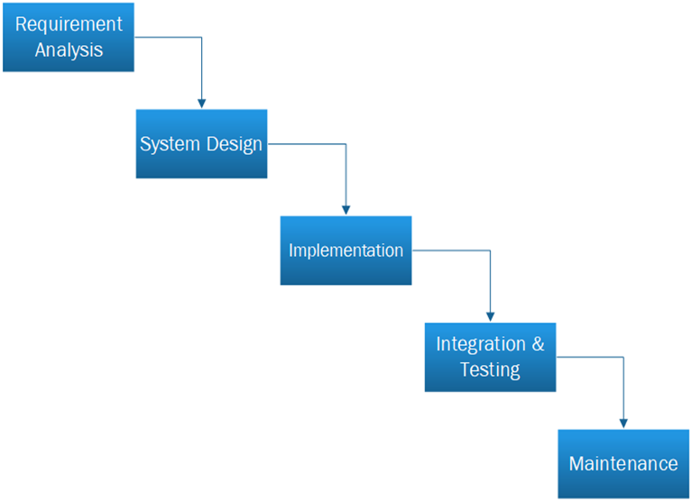
Figure ‎1.1 Waterfall Model Flow Diagram

1.11 Nature of the Project
This project is primarily a Research and Development (R&D) endeavor focused on exploring the application of artificial intelligence and web technologies to address challenges in respiratory health management. The initial phase involves extensive research into the viability and efficacy of AI-driven audio analysis and smart diagnosis in this field, despite the ultimate objective of creating a useful tool for individuals. Because it involves the design, development, and testing of a complex web application with a variety of interconnected features, the project also incorporates elements of software development. Furthermore, it touches upon Healthcare Technology, aiming to provide a digital solution that can potentially improve health outcomes and empower individuals in managing their well-being.
The interdisciplinary nature of the project, combining expertise in software development, artificial intelligence, and an understanding of healthcare needs, makes it a multifaceted undertaking.

1.12 Process Flow
We will describe the flow of our project through a flowchart
1.12.1 Overall System’s user Flow
Figure 1.2 shows the overall system’s user flow.
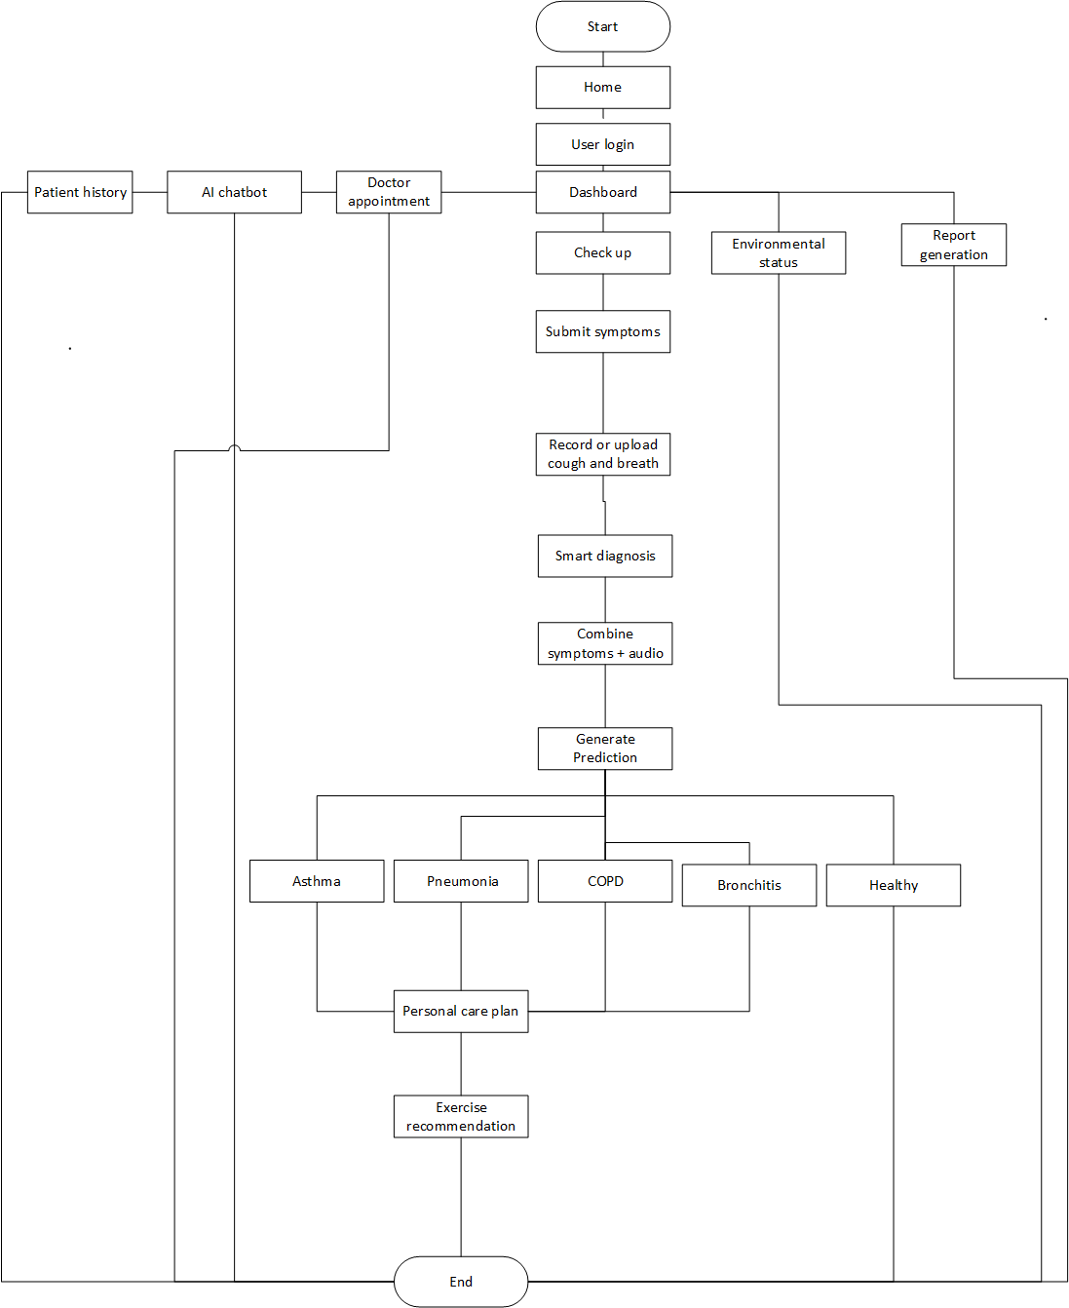
Figure ‎1.2 Overall system's user flow
1.12.2 Flowchart for symptom submission
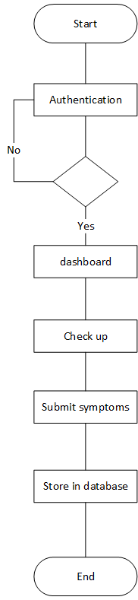
Figure 1.3 show the flow of symptom submission.
Figure ‎1.3 Flowchart for symptom submission

1.12.3 Flowchart for cough and breath record
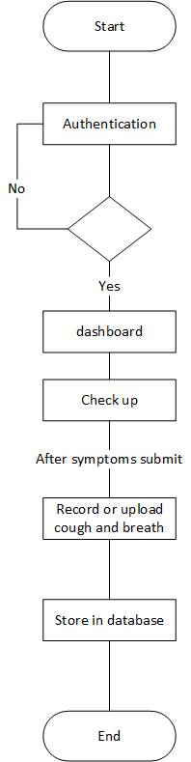
Figure 1.4 show the flow of cough recording
Figure ‎1.4 Flowchart for cough and breath record

1.12.4 Flowchart for smart diagnosis
Figure 1.5 shows how smart diagnosis combine symptoms and cough to predict diseases
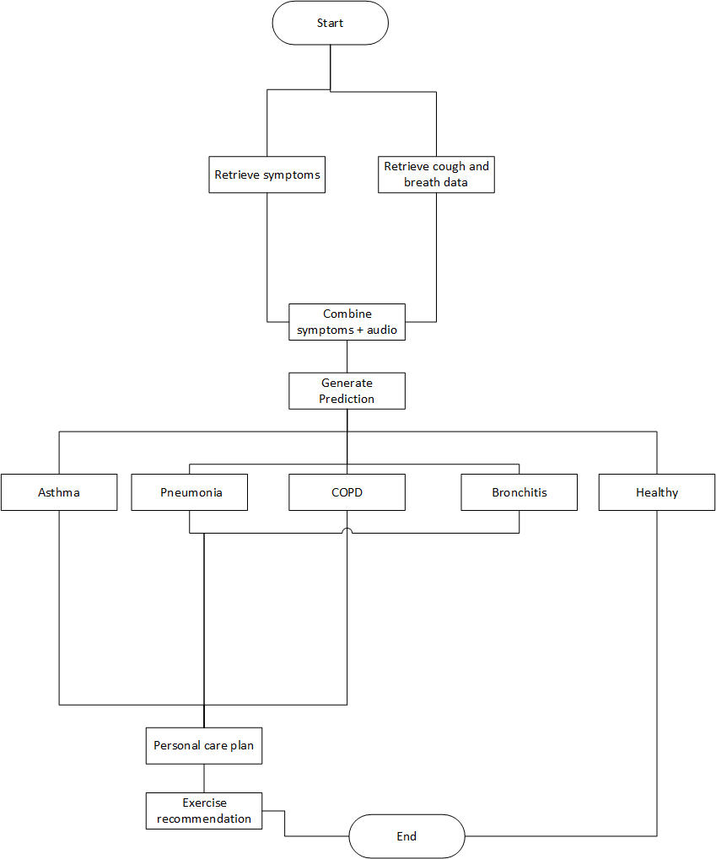
Figure ‎1.5 Flowchart for smart diagnosis

1.13 Milestone
Figure 1.6 shows the overall milestone of the project.

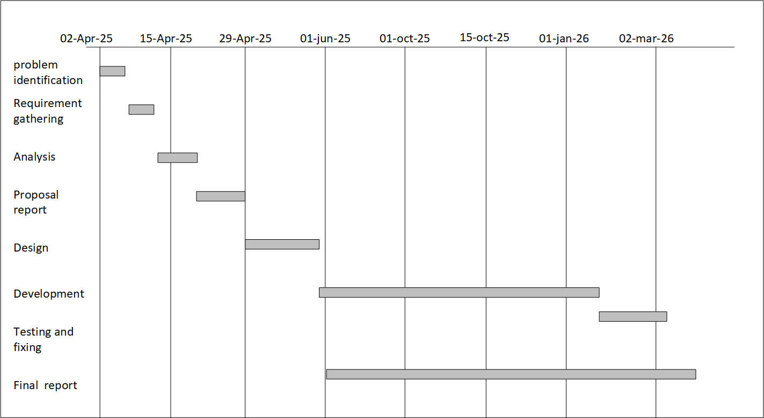
Figure ‎1.6 Gantt chat

1.14 Overview
Chapter 1, "Introduction," establishes the critical context for the BreatheWell project by highlighting the global challenge of respiratory diseases and the limitations in current detection and management. It outlines the motivations for developing an AI-powered web application, clearly defines the problems BreatheWell aims to solve, and introduces the proposed system with its core features. The chapter then sets the project's direction by detailing its goals and objectives, delineates the scope of the current study, and provides an overview of the technologies, team expertise, and the Incremental development process. Finally, it offers a glimpse into the project's flow, key milestones, and a roadmap for the subsequent chapters, providing a comprehensive foundation for understanding the BreatheWell initiative.

BACKGROUND AND EXISTING WORK

2.1 Introduction
In this chapter, we will explore the background of the BreatheWell software project. We'll look at some existing systems for respiratory health monitoring and highlight their features and limitations. By comparing these systems with BreatheWell, we will show how it offers a more complete solution.

2.2 Key Components of the BreatheWell System
BreatheWell has several important components that make it work:

2.2.1 Frontend – React
React is a popular JavaScript library used to build interactive user interfaces. It's chosen for BreatheWell because:
- It allows us to create reusable UI components.
- It is fast and updates the page efficiently with its Virtual DOM.
- It has a large community and many useful libraries.
- It easily connects with the backend to show real-time health data.

2.2.2 Backend
The backend of BreatheWell is built using either Node.js or Django, each offering unique advantages:
Flask
- Provides security and efficiency for handling large health data.
- Comes with an admin panel to manage user data and health records easily.

2.2.3 Artificial Intelligence – Machine Learning and Deep Learning
Cough and Breathing Sound Analysis (Deep Learning)
- Deep learning models (like CNNs, RNNs, or specialized audio classification models) are used to analyze cough and breathing sounds recorded by the user.
- The system learns to detect patterns or abnormalities in audio that may be linked to diseases like asthma, bronchitis, pneumonia.
- Instead of manually analyzing sounds, the deep learning model automatically predicts if the sound is normal or abnormal.
Smart Diagnosis System (Machine Learning)
- Machine learning models (such as Decision Trees, Random Forest, SVM, or Ensemble Methods) are used to combine the symptom data (from user input) and audio analysis results.
- The ML model predicts the most likely respiratory condition based on the combined data.
- This helps in early and automated detection without waiting for a doctor’s manual evaluation.

2.2.4 Database
BreatheWell uses MongoDB databases to store and manage health data. These databases offer:
Scalability and flexibility to handle large amounts of data.
Secure and efficient data storage with real-time updates.

2.3 Existing Systems
Several healthcare apps exist to monitor general health or lung conditions. Notable examples include:
- Ada Health [3]: A general health app with AI-based symptom checking.
- AsthmaMD [4]: An app designed specifically for managing asthma.
- ResApp Health [5]: Uses cough sound analysis to diagnose lung conditions.
- Hyfe App [6]: Focuses on cough analysis for lung health.
These apps are useful but have limitations that BreatheWell aims to address.

2.4 Limitations of Existing Systems

2.4.1 Ada Health
- Symptoms: Tracks general health but not specifically respiratory conditions.
- Limitations:

  - No cough or breath analysis.
  - No real-time lung health monitoring.
  - No personalized treatment plans or environmental alerts.

2.4.2 AsthmaMD
- Symptoms: Designed for asthma management, tracking asthma symptoms.
- Limitations
  - Only focuses on asthma, not other conditions like COPD or pneumonia.
  - No cough or breath sound analysis.
  - No environmental or personalized care alerts.

2.4.3 ResApp Health
- Symptoms: Diagnoses conditions like asthma using cough sound analysis.
- Limitations
  - No continuous symptom tracking.
  - Lacks personalized treatment or environmental alerts.

2.4.4 Hyfe App
- Symptoms: Focuses on analyzing cough sounds.
- Limitations
  - Only tracks cough, not other respiratory symptoms.
  - No environmental or personalized care alerts.

2.5 Comparison Table of Existing Systems vs. BreatheWell
Table 2.1 shows the comparison between existing system and the proposed system (BreatheWell).

Table ‎2.1 Existing Systems vs. BreatheWell
Feature | Ada Health | AsthmaMD | ResApp Health | Hyfe App | Proposed System
Cough & Breath Analysis | No | No | Yes | Yes | Yes
Symptom Tracking | Yes | Yes | No | Yes | Yes
Personalized Treatment Plans | Yes | Yes | No | No | Yes
Environmental Alert System | No | No | No | No | Yes
Chatbot assistant | No | No | No | No | Yes
Doctor appointment | No | No | No | No | Yes
History tracking | No | No | No | No | Yes
Exercise recommendation | No | No | No | No | Yes

2.6 Summary
This chapter has reviewed existing healthcare systems that monitor respiratory health. While platforms like Ada Health, AsthmaMD, ResApp Health, and Hyfe App provide useful features, none of them offer a comprehensive solution for lung health. BreatheWell overcomes these gaps by combining cough and breath analysis, symptom tracking, personalized care plans, environmental alerts, and chatbot triage.

REQUIREMENTS SPECIFICATION

3.1 Introduction
This chapter formally outlines the detailed requirements for the BreatheWell AI-powered web application, an innovative respiratory health monitoring system. It defines the necessary resources and specifications for its development and operation, categorizing the system's needs into functional and non-functional requirements. These requirements ensure that the system meets its goals of providing non-invasive, AI-driven detection, tracking, and personalized care for respiratory conditions such as asthma, COPD, pneumonia, and bronchitis. Finally, the chapter visualizes the primary user-system interactions through a Use Case Diagram and provides detailed descriptions of the key use cases.

3.2 Interface Requirements
The successful development and deployment of BreatheWell require hardware, software and human expertise resources.

3.2.1 Hardware Requirements
The minimum hardware specifications for development and better performance are:
- Processor: Laptop/PC with a Core i3-4th Generation or above.
- RAM: 4GB or above.
- User Devices: Devices (smartphones, PCs) must have a reliable microphone for recording cough and breathing sounds.

3.2.2 Software Requirements
This covers the operating systems, development tools, frameworks, and databases required.
- Frontend: React.js is used to create a dynamic and responsive user interface.
- Backend & Logic: Python is chosen for its extensive libraries in data science and machine learning, with frameworks such as Django or Flask managing API development and server-side logic.
Node.js is also considered for the backend.
- Artificial Intelligence: Machine Learning and Deep Learning algorithms are utilized for analyzing respiratory sounds and smart diagnosis.
- Database: MongoDB (a popular NoSQL database) are utilized for efficient data management.
- Authentication/Real-time: Firebase is used for authentication, real-time user-system communication, and implementation of OTP and messaging.
- Design & Modelling: Figma is used for designing and modeling.

3.3 Functional Requirements
Functional requirements define the specific actions or services the BreatheWell system must perform for the user.

3.3.1 Signup
Table 3.1 shows the user registration functional requirement
Table ‎3.1 Signup
FR-01 | Signup
Description | The system shall enable the user to register their account.
Priority | High

3.3.2 Login
Table 3.2 shows the user Login functional requirement
Table ‎3.2 Login
FR-02 | Login
Description | The system shall provide a login to the user.
Priority | High

3.3.3 Symptom Submission
Table 3.3 shows the Symptom Submission functional requirement.
Table ‎3.3 Symptom Submission
FR-03 | Symptom Submission
Description | The system must provide a user-friendly interface for users to easily record and submit information about their current respiratory symptoms
Priority | High

3.3.4 Audio Recording/Upload
Table 3.4 shows the Audio Recording/Upload functional requirement.
Table ‎3.4 : Audio Recording/Upload
FR-04 | Audio Recording/Upload
Description | The system must allow users to record or upload cough and breathing sounds through an intuitive web interface.
Priority | High

3.3.5 AI Audio Analysis
Table 3.5 shows the AI Audio Analysis functional requirement.
Table ‎3.5 AI Audio Analysis
FR-05 | AI Audio Analysis
Description | The system must leverage deep learning to analyze uploaded/recorded audio samples to identify respiratory patterns, such as dry/wet coughs, wheezing, and irregular breathing.
Priority | High

3.3.6 Smart Diagnosis
Table 3.6 shows the Smart Diagnosis functional requirement.
Table ‎3.6 Smart Diagnosis
FR-06 | Smart Diagnosis
Description | The system must combine submitted symptom data with the results of the audio analysis to provide an AI-driven prediction of potential lung conditions.
Priority | High

3.3.7 Personalized Care Plan Generation
Table 3.7 shows the Personalized Care Plan Generation functional requirement.
Table ‎3.7 Personalized Care Plan Generation
FR-07 | Personalized Care Plan Generation
Description | The system must generate tailored recommendations, including home remedies, lifestyle adjustments, and professional guidance, based on the system's analysis and diagnosis.
Priority | High

3.3.8 Dashboard
Table 3.8 shows the Dashboard functional requirement.
Table ‎3.8 Dashboard
FR-08 | Dashboard
Description | The system must provide a visual platform (dynamic dashboard) from where users can to other functionalities.
Priority | High

3.3.9 Environmental Alerts
Table 3.9 shows the Environmental Alerts functional requirement.
Table ‎3.9 : Environmental Alerts
FR-09 | Environmental Alerts
Description | The system must monitor real-time air quality in the user's area to issue timely alerts and preventive health advice that may impact respiratory health.
Priority | High

3.3.10 AI Chatbot Support
Table 3.10 shows the AI Chatbot Support functional requirement.
Table ‎3.10 AI Chatbot Support
FR-10 | AI Chatbot Support
Description | The system must include an integrated AI chatbot for real-time assistance, providing immediate support and answering common queries.
Priority | High

3.3.11 Patient History Tracking
Table 3.11 shows the Patient History Tracking functional requirement
Table ‎3.11 Patient History Tracking
FR-11 | Patient History Tracking
Description | The system must maintain a detailed, comprehensive record of each user's past symptoms, diagnoses, AI predictions, and care plans.
Priority | High

3.3.12 Report Generation
Table 3.12 shows the Report Generation functional requirement
Table ‎3.12 Report Generation
FR-12 | Report Generation
Description | The system must allow users to generate and download detailed health reports summarizing their symptoms, diagnostic results, and care plans.
Priority | High

3.3.13 Exercise Recommendation
Table 3.13 shows the Exercise Recommendation functional requirement
Table ‎3.13: Exercise Recommendation
FR-13 | Exercise Recommendation
Description | The system must suggest appropriate breathing exercises and physical activities tailored to the user's specific respiratory condition to improve lung function.
Priority | High

3.3.14 Schedule Doctor appointment
Table 3.14 shows the doctor appointment functional requirement
Table ‎3.14 Schedule Doctor appointment
FR-14 | Schedule Doctor appointment
Description | The system must allow user to request doctors for appointment
Priority | High

3.3.15 See Appointment Request
Table 3.15 shows the see appointment request functional requirement
Table ‎3.15 see appointment request
FR-15 | See Appointment Request
Description | The system must allow doctor to see appointment requests
Priority | High

3.4 Non-Functional Requirements
Table 3.16 shows non-functional requirements specify the criteria for judging the quality of the system's operation.
Table ‎3.16: Non-functional requirements
ID | Non-Functional Requirement | Description
NFR-1 | AI Processing Speed | The AI-powered analysis and Smart Diagnosis System must process and return a prediction in a timely manner to provide real-time insights
NFR-2 | Scalability | The full-stack architecture must support scalability to efficiently manage a potentially large volume of user health data
NFR-3 | Data Privacy | The system must safeguard user data privacy to ensure secure access to personal health information.
NFR-4 | Authentication Security | The complete authentication system must be secure to prevent unauthorized access to personal health records.
NFR-5 | User Interface | The interface must be dynamic, responsive, and intuitive to make it easy for users to submit symptoms and upload or record sounds.
NFR-6 | Accessibility | The web application must be accessible, bridging the gap for individuals who have limited access to specialized healthcare facilities or affordable screening tools.
NFR-7 | System Integrity | The system must reliably analyze respiratory patterns and cross-reference symptom data for comprehensive and accurate insights.

3.5 Use Case Diagram
A Use Case Diagram visually represents the functionality of the BreatheWell system in terms of actors (users) and use cases (functions). The primary actor is the Registered User.
Figure 3.1 shows the use case diagram for our system.

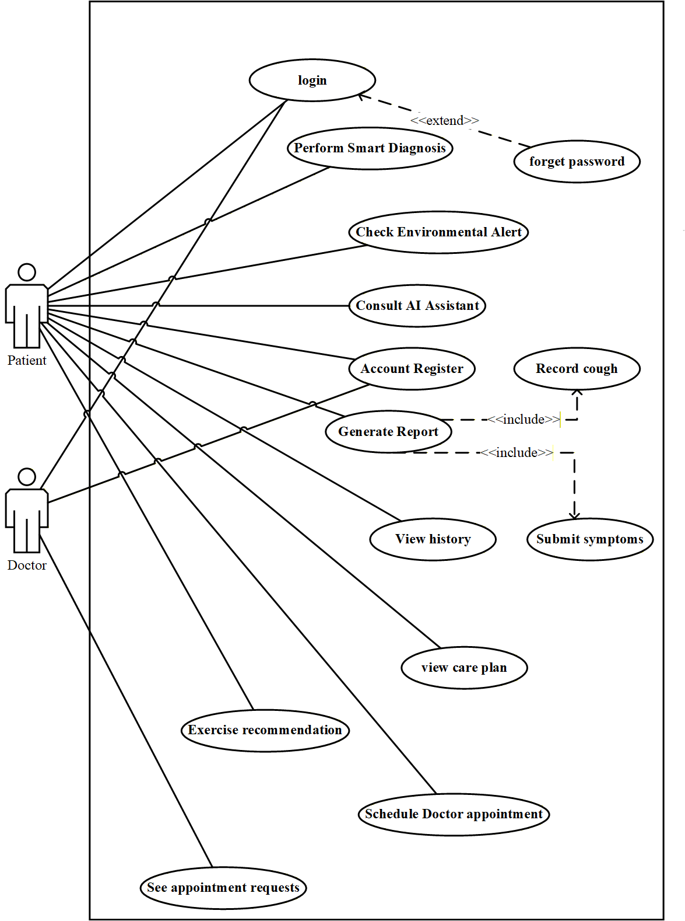
Figure ‎3.1 use case diagram

3.6 Use Cases Description
Detailed descriptions for use cases that define the functionality of BreatheWell.

3.6.1 Perform Smart Diagnosis
The system must combine submitted symptom data with the results of the audio analysis to provide an AI-driven prediction of potential lung conditions
Table ‎3.17: Perform Smart Diagnosis
Use Case ID | UC-01
Use Case Name | Perform Smart Diagnosis
Primary Actor | Registered User
Goal | To obtain an AI-driven prediction of a potential respiratory condition and receive a personalized care plan.
Preconditions | The User must be logged into the system .
Flow of Events | 1. User navigates to the "Check-up" section.  2. User submits their current respiratory symptoms .  3. System stores symptom data.  4. User records or uploads a sample of their cough/breathing sounds .  5. System stores the audio file.  6. System's AI model analyzes the audio for patterns like wheezing or irregular breathing.  7. System's Smart Diagnosis module combines symptom data and audio analysis results.  8. System generates a predicted diagnosis.  9. System displays the diagnosis and a personalized care plan.
Postconditions | A new record of the check-up, including symptoms, audio analysis, and diagnosis, is saved in the Patient History .
Cross reference | FR-06

3.6.2 View History
The system must provide a visual platform (dynamic dashboard) where users can monitor their symptoms over time, track trends, and view detailed health reports.
Table ‎3.18: View History
Use Case ID | UC-02
Use Case Name | View History
Primary Actor | Registered User
Goal | To review historical health data and observe symptom trends over time.
Preconditions | The User must be logged in and have prior check-up data recorded (FR-10).
Flow of Events | 1. User navigates to the "Dashboard" section.  2. Select patient history  3. System retrieves the user's detailed health history, including submitted symptoms, diagnostic results, and care plans .  3. System visually displays the data, showing trends and progress over time .
Postconditions | The user has reviewed their respiratory health journey, and a downloadable health report may be generated.
Alternative flow | 3a. If user is new then show no record found
Cross reference | FR-11

3.6.3 Check Environmental Alert
The system must monitor real-time air quality in the user's area to issue timely alerts and preventive health advice that may impact respiratory health.
Table ‎3.19: Check Environmental Alert
Use Case ID | UC-03
Use Case Name | Check Environmental Alert
Primary Actor | Registered User
Goal | To be proactively warned about local air quality conditions that may affect respiratory health.
Preconditions | The User is logged in and the system has access to the user's location or pre-set location.
Flow of Events | 1. System continuously integrates real-time air quality data (using public APIs).  2. System analyzes the data against thresholds that may impact respiratory health.  3. If a risk is detected, the system issues a timely alert to the user .  4. The alert includes preventive advice to help the user avoid exposure to harmful environmental conditions.  5. User views the notification on the dashboard or in an alert system area.
Postconditions | The user is informed of the environmental risk and advised on precautionary actions.
Cross reference | FR-10

3.6.4 Account Register
The system shall enable the user to register their account. The system shall provide a login to the user.
Table ‎3.20: Account Register
Use Case ID | UC-04
Use Case Name | Account Register
Primary Actor | User (patient or doctor)
Goal | To securely access or register for the BreatheWell system.
Preconditions | The User must have an active internet connection.
Flow of Events | 1. User selects "Sign Up" option.  2. User provides required details (name, email, secure password).  3. System hashes and salts the password before storage .  4. System creates a new user account and directs the user to the Dashboard.
Postconditions | The User is either securely logged into the system or a new, registered account has been created .
Alternative flow | 3a. If user already exist show user already exist, please login
Cross reference | FR-01

3.6.5 Consult AI Assistant
The system must include an integrated AI chatbot for real-time assistance, providing immediate support and answering common queries.
Table ‎3.21 Consult AI Assistant
Use Case ID | UC-05
Use Case Name | Consult AI Assistant
Primary Actor | Registered User
Goal | To receive immediate, real-time answers or guidance on general respiratory health queries.
Preconditions | The User must be logged into the system.
Flow of Events | 1. User selects the "AI Chatbot" icon or section.  2. System loads the Chatbot interface .  3. User types a query related to symptoms, conditions, or general health.  4. The Chatbot processes the natural language input.  5. Chatbot retrieves the most relevant information or suggested next steps (e.g., "submit a check-up").  6. Chatbot displays the response to the user in real-time.  7. User continues the conversation or closes the chatbot window.
Postconditions | The User has received information or assistance, and the interaction is logged for future model training/improvement.
Cross reference | FR-05

3.6.6 Generate Report
The system must allow users to generate and download detailed health reports summarizing their symptoms, diagnostic results, and care plans.
Table ‎3.22: Generate Report
Use Case ID | UC-06
Use Case Name | Generate Report
Primary Actor | Registered User
Goal | To produce a printable/downloadable summary of the User's health history for sharing with a healthcare provider.
Preconditions | The User must be logged in and have prior health data recorded
Flow of Events | 1. User navigates to the "Patient History" or "Dashboard" section.  2. User selects the "Generate Report" option.  3. System generate the report based on the symptoms and cough diagnosis result  4. System formats the data into a structured, professional PDF document.  5. System presents the User with the option to view, print, or download the generated report.
Postconditions | A comprehensive, structured health report is generated and made available to the User .
Alternative flow | 3a. if user did not perform AI diagnosis at least once, Prompt for symptoms and cough diagnosis before generating report
Cross reference | FR-12

3.6.7 Submit Symptoms
The system must allow users to submit their symptoms to predict possible respiratory condition.
Table ‎3.23: Submit Symptoms
Use Case ID | UC-07
Use Case Name | Submit Symptoms
Primary Actor | Registered User
Goal | To submit symptoms for AI-driven prediction
Preconditions | The User must be logged into the system.
Flow of Events | 1. User navigates to the "Check-up" section.  2. User submits their current respiratory symptoms.  3. System stores symptom data.
Postconditions | A new record of the symptoms is saved in the Patient History.
Cross reference | FR-03

3.6.8 Record Cough
The system must allow users to submit their symptoms to predict possible respiratory condition.
Table ‎3.24: Record Cough
Use Case ID | UC-08
Use Case Name | Record Cough
Primary Actor | Registered User
Goal | To record cough for AI-driven prediction
Preconditions | The User must be logged into the system (FR-1).
Flow of Events | 1. User navigates to the "Check-up" section.  2. User submits their current respiratory symptoms.  3. System stores symptom data.  4. User records or uploads a sample of their cough sounds.  5. System stores the audio file.
Postconditions | A new record of the cough is saved in the Patient History.
Cross reference | FR-04

3.6.9 View Care Plan
The system must allow users to see detailed health care plan summarizing their symptoms, diagnostic results.
Table ‎3.25: View Care Plan
Use Case ID | UC-09
Use Case Name | View Care Plan
Primary Actor | Registered User
Goal | To see user’s care plan based on the symptoms and result.
Preconditions | The User must be logged in and have prior health data recorded
Flow of Events | 1. User navigates to the "Dashboard" section.  2. User selects the "view care plan" option .  3. System securely retrieves the care plan.  4. System display the detail care plan.
Postconditions | A comprehensive, structured health care plan is generated and made available to the User .
Alternative flow | 3a. If user is new system shows record not found
Cross reference | FR-07

3.6.10 Schedule Doctor Appointment
The system must allow users to get appointment from a doctor.
Table ‎3.26: Schedule Doctor Appointment
Use Case ID | UC-10
Use Case Name | Schedule Doctor Appointment
Primary Actor | Registered User
Goal | To get an appointment from a doctor.
Preconditions | The User must be logged in and have prior health data recorded
Flow of Events | 1. User navigates to the "Dashboard" section.  2. User selects the "doctor appointment" option .  3. System show available doctors  4. System securely retrieves the user’s details like symptoms and allow user to send to the doctor.
Postconditions | System show an appointment detail with date and location.
Alternative flow | 4. Show patient report not found, if user try to request appointment without AI diagnosis.
Cross reference | FR-14

3.6.11 Exercise Recommendation
The system allow users to see detailed recommended exercise based on the patient’s condition.
Table ‎3.27: Exercise Recommendation
Use Case ID | UC-11
Use Case Name | Exercise Recommendation
Primary Actor | Registered User
Goal | To see recommended exercise.
Preconditions | The User must be logged in and have prior health data recorded
Flow of Events | 1. User navigates to the "Dashboard" section.  2. User selects the "exercise" option .  3. System securely retrieves the specific recommended exercise.  4. System display the detail exercise steps.
Alternative flow | 3a. If user is new and no any patient report then show no recommendation yet.
Postconditions | The recommended exercise details are successfully displayed to the User.
Cross reference | FR-13

3.6.12 See Appointment Request
The system allow doctor to see appointment request with patient details.
Table ‎3.28: See Appointment Request
Use Case ID | UC-12
Use Case Name | See Appointment Request
Primary Actor | Registered doctor
Goal | To see appointment requests from patient and schedule an appointment.
Preconditions | The User must be logged in
Flow of Events | 1. User navigates to the "Dashboard" section.  2. User selects the " appointment requests " option .  3. System list the appointment requests.
Postconditions | The request details are successfully displayed to the doctor.
Alternative flow | 3a. No request yet at the movement if request did not send from any patient.
Cross reference | FR-15

3.7 Summary
Chapter 3 has established the foundational requirements specification for the BreatheWell system. It defined the necessary hardware and software resources and clearly detailed the expected functional requirements, covering all core features from secure authentication to the AI-driven Smart Diagnosis. Crucially, non-functional requirements were established to ensure the system is secure, performs well, and is reliable. Finally, a Use Case Diagram and Use Case Descriptions provided a clear, structural view of how the user will interact with the system's key functionalities, paving the way for the detailed system design and architecture in the subsequent chapter.

SYSTEM MODELING

4.1 Introduction
This chapter focuses on the architectural design and modeling of the BreatheWell system, translating the defined functional and non-functional requirements (from Chapter 3) into a clear technical structure. It details the overall system architecture, defines the user interface design principles, and utilizes the 4+1 View Model to present a multi-faceted view of the software architecture. This modeling effort lays the foundation for the successful implementation of the AI-powered respiratory health monitoring application.

4.2 System Design
The BreatheWell system adopts a modern Three-Tier Architecture integrated with specialized services for Artificial Intelligence and external data retrieval. This approach ensures separation of concerns, scalability, and maintainability.

4.2.1 Architectural Overview (Three-Tier Model)
The system is divided into three logical layers:
- Presentation Tier (Frontend)
  - Technology: Developed using React.js.
  - Function: Handles the User Interface (UI), user experience (UX), and client-side interactions. This layer runs on the user's browser or mobile device, allowing users to submit symptoms, record/upload audio, view dashboards, and interact with the AI chatbot.
- Application/Logic Tier (Backend API)
  - Technology: Developed using Python (Flask/Django) or Node.js.
  - Function: Acts as the intermediary between the frontend and the data/AI services. It executes all business logic, including user authentication, processing form submissions, managing sessions, calling the AI Analysis Service, generating personalized care plans, and serving data to the dashboard.
- Data Tier (Databases & Storage)
  - Technology: MongoDB (for potentially unstructured or rapidly changing data, like chatbot logs). Dedicated storage for user-uploaded audio files.
  - Function: Securely stores and manages all application data, including user profiles, symptom history, diagnostic results, and configuration settings.

4.2.2 Specialized Services and Interoperability
The core functionality relies on two main services integrated with the Logic Tier:
- AI Analysis Service: A dedicated microservice, likely implemented in Python with TensorFlow/PyTorch, responsible solely for running the trained Machine Learning models (FR-4). It receives raw audio data from the Logic Tier and returns the analyzed respiratory patterns and smart diagnosis prediction (FR-5).
- External API Gateway: Handles communication with third-party services, primarily the Air Quality Index (AQI) API to fetch real-time environmental data necessary for Environmental Alerts.

4.3 Interface Design
Interface design focuses on creating a user-friendly, accessible, and intuitive experience. The design adheres to modern web standards, prioritizing responsiveness for optimal use on both mobile and desktop devices.

4.3.1 User Interface (UI) Components
- Dashboard: A central hub showing the user's current health status, recent diagnosis, and key historical trends. It utilizes clear visual aids like charts and graphs.
- Check-up Module: A multi-step, clean interface guiding the user through symptom submission and audio recording/upload. Visual feedback is crucial here to confirm successful recording.
- Alerts Panel: A dedicated area for prominently displaying Environmental Alerts and appointment notifications.
- Navigation: A simple, persistent navigation structure (sidebar or bottom tab bar on mobile) provides quick access to main sections:

4.3.2 Design Principles
- Clarity and Simplicity: Minimalist design to reduce cognitive load, focusing user attention on health data and next steps.
- Visual Feedback: Immediate feedback for critical actions, such as confirming audio upload or diagnosis calculation.
- Accessibility: Use of high contrast color palettes and proper font sizes to ensure readability for users of all abilities.

4.4 The 4+1 View Model of Architecture
The 4+1 View Model, introduced by Philippe Kruchten in 1995, provides a comprehensive structure for documenting software architecture by separating it into five concurrent views. This separation ensures that the unique concerns of all stakeholders from end-users to system engineers are effectively addressed.
The model consists of:
Logical View: Captures the system's functionality and key abstractions.
Process View: Deals with the dynamic aspects of runtime behavior.
Development View: Focuses on the static organization of the software in its development environment.
Physical View: Illustrates the system's deployment onto hardware nodes.
Scenarios (+1): The unifying view that validates the architecture through practical use cases.
Figure 4.1 represents the 4 + 1 view model of Architecture.

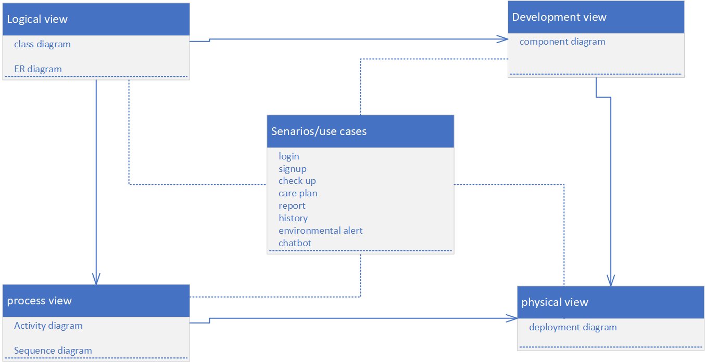
Figure ‎4.1 4+1 view model

4.4.1 Logical View
This view focuses on the system's functional requirements describing the design object model and the system's class and module structure.

4.4.1.1 UML Class Diagram
The Class Diagram is used to show the static, object-oriented structure of the system's business concepts. It is essential for the software developer stakeholder.
- Focus: Core system concepts, their attributes, methods (functions), and relationships (inheritance, association, aggregation).
- Purpose in BreatheWell: To model the classes in the application logic layer.
Figure 4.2 shows the class diagram of our system (BreatheWell).

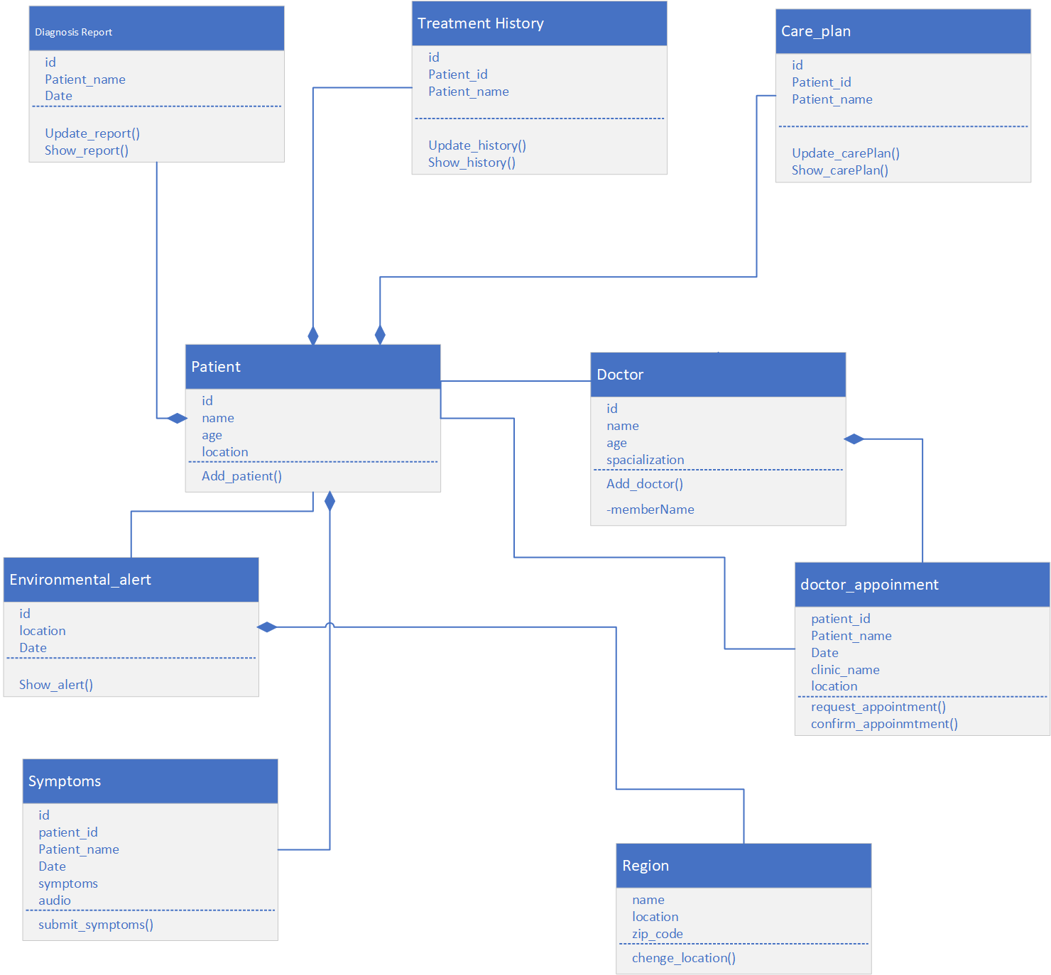
Figure ‎4.2 class diagram

4.4.1.2 Entity-Relationship Diagram (ERD)
The ERD is used to model the structure of the data stored in the database. It is essential for the database designer and helps validate the data-centric requirements.
- Focus: Entities (tables), attributes (columns), and the relationships between entities (one-to-one, one-to-many, many-to-many).
- Purpose in BreatheWell: To design the robust schema for the Data Tier (MongoDB). It ensures that all patient history and diagnostic data are securely and efficiently stored.
Figure 4.3 represent the Entity Relationship diagram of our system.
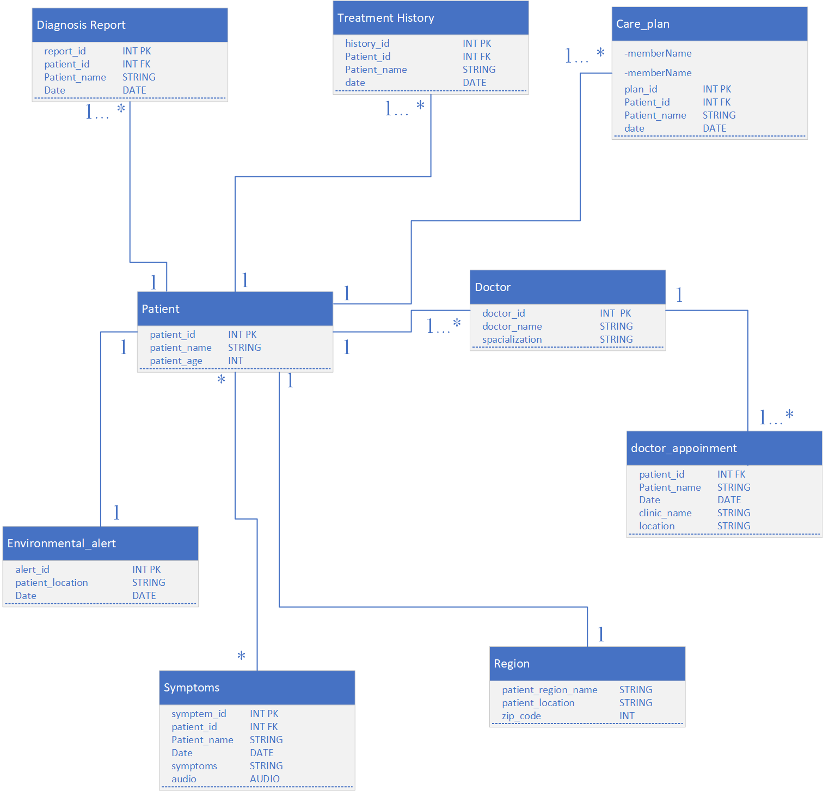
Figure ‎4.3 ERD for BreatheWell

4.4.2 Process View
The Process View addresses the system's dynamic aspects, focusing on the execution of tasks. It shows how the system will perform in different scenarios.

4.4.2.1 Activity Diagram
The Activity Diagram models the flow of control within the system, focusing on the step-by-step actions required to complete a business process. It is used to show the workflow from one activity to the next, often demonstrating parallel activities.
Figure 4.4 shows the overall activity diagram of our system.
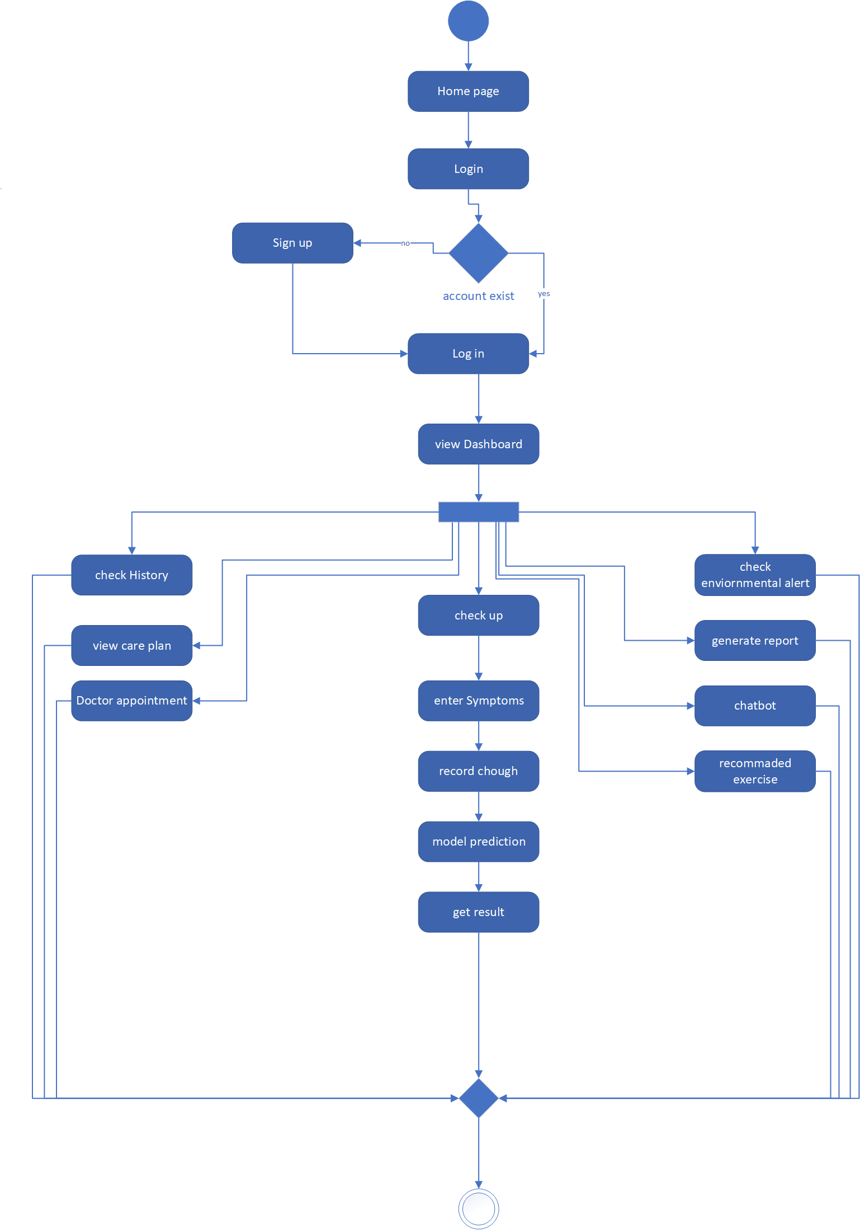
Figure ‎4.4 Activity diagram

4.4.2.2 Sequence Diagram
The Sequence Diagram models the time-ordered interactions between objects or components to complete a specific task.
4.4.2.2.1 Sequence Diagram for Smart Diagnosis Check-up
Figure 4.5 illustrates the interaction flow when a registered user performs a Smart Diagnosis Check-up using the BreatheWell system.
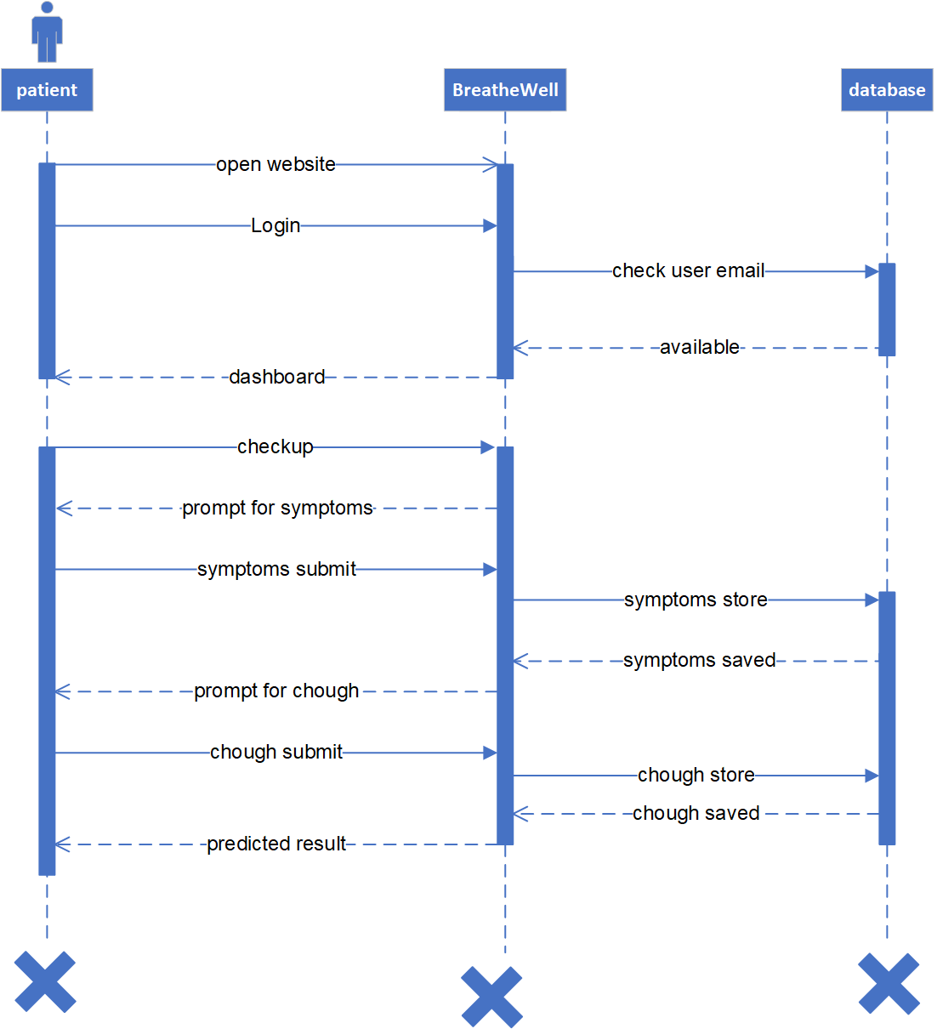
Figure ‎4.5 Sequence Diagram for Smart Diagnosis Check-up

4.4.2.2.2 Track Health History
Figure 4.6 models the flow when a user accesses their health history, symptom logs, and past diagnosis records.
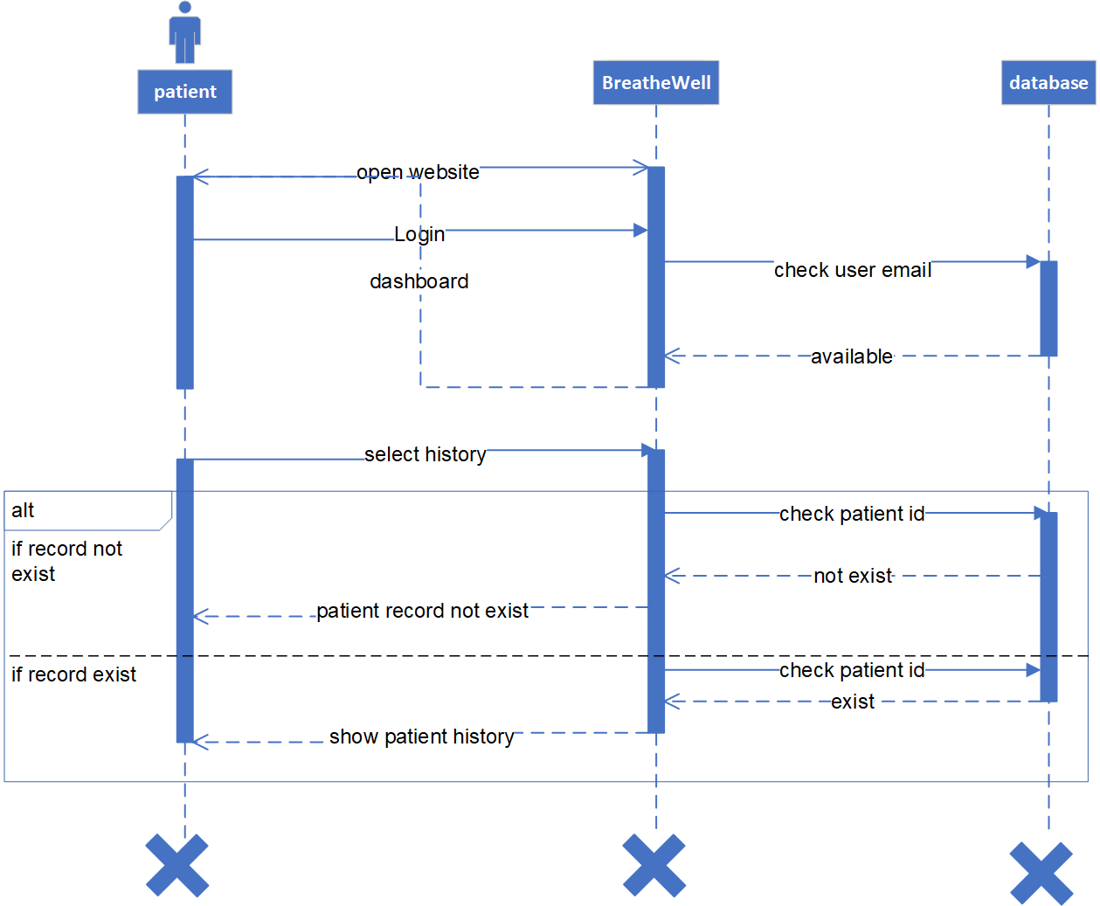
Figure ‎4.6 sequence diagram for Track Health History

4.4.2.2.3 Receive Environmental Alert
Figure 4.7 models the background process of checking Air Quality Index (AQI) and notifying the user .
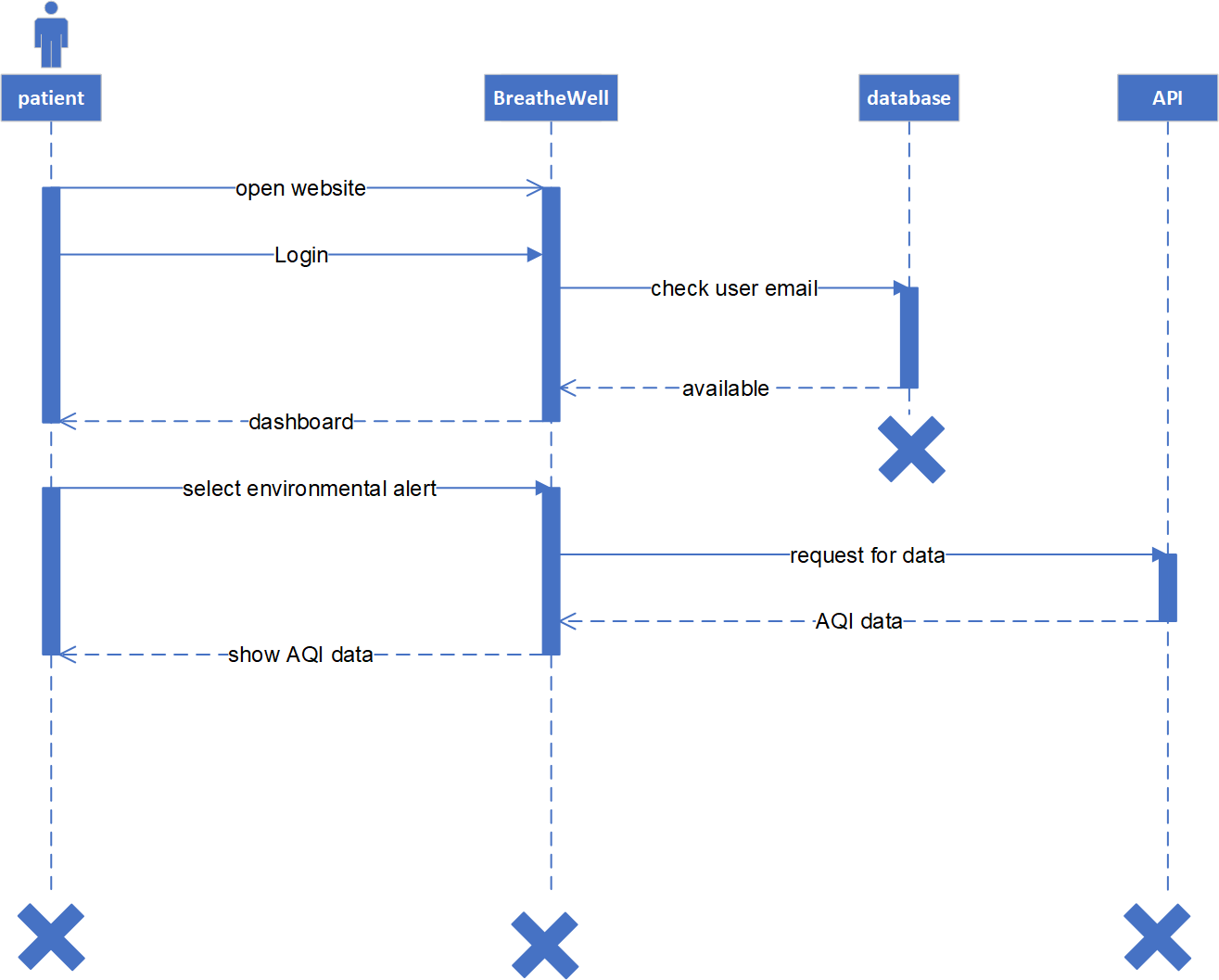
Figure ‎4.7 sequence diagram for Receive Environmental Alert

4.4.2.2.4 Interact with AI Chatbot
Figure 4.8 models a real-time, interactive session with the AI Chatbot
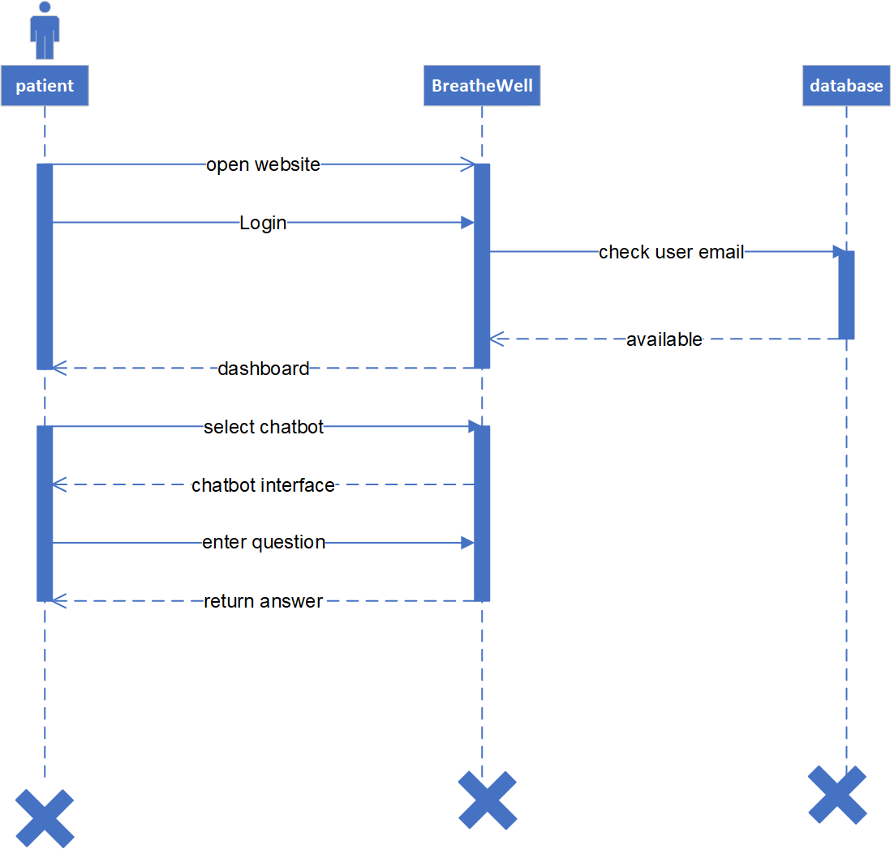
Figure ‎4.8 sequence diagram for Interact with AI Chatbot

4.4.2.2.5 Generate Report
Figure 4.9 models the process of compiling user data into a single, structured, and downloadable document.
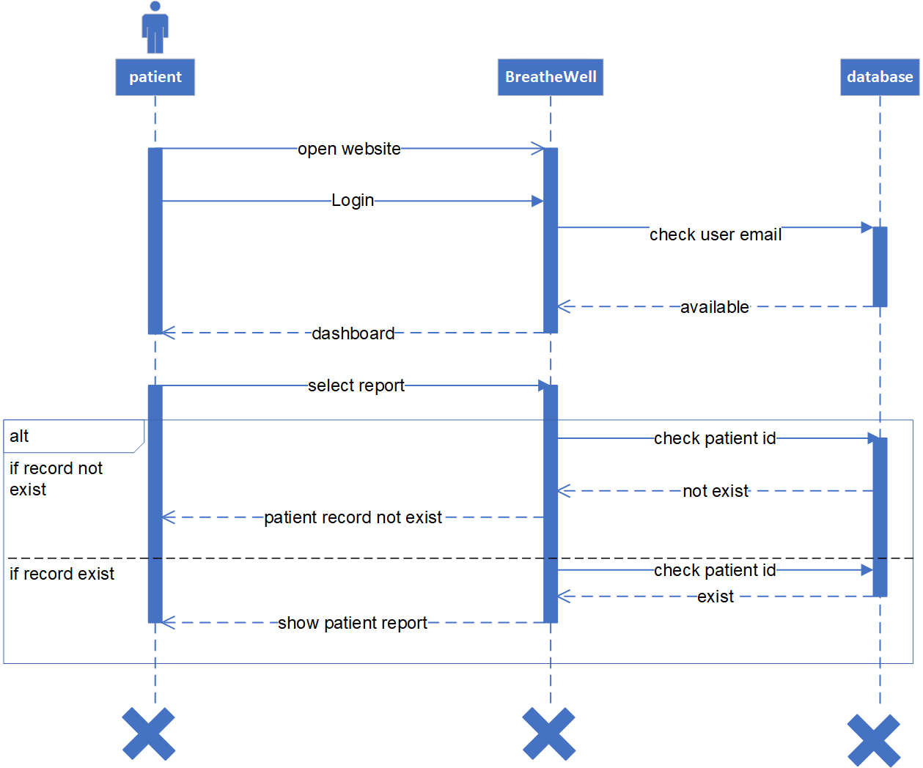
Figure ‎4.9 sequence diagram for Health Report

4.4.2.2.6 Account Register
Figure 4.10 models the process of creating a new user’s account on the system.
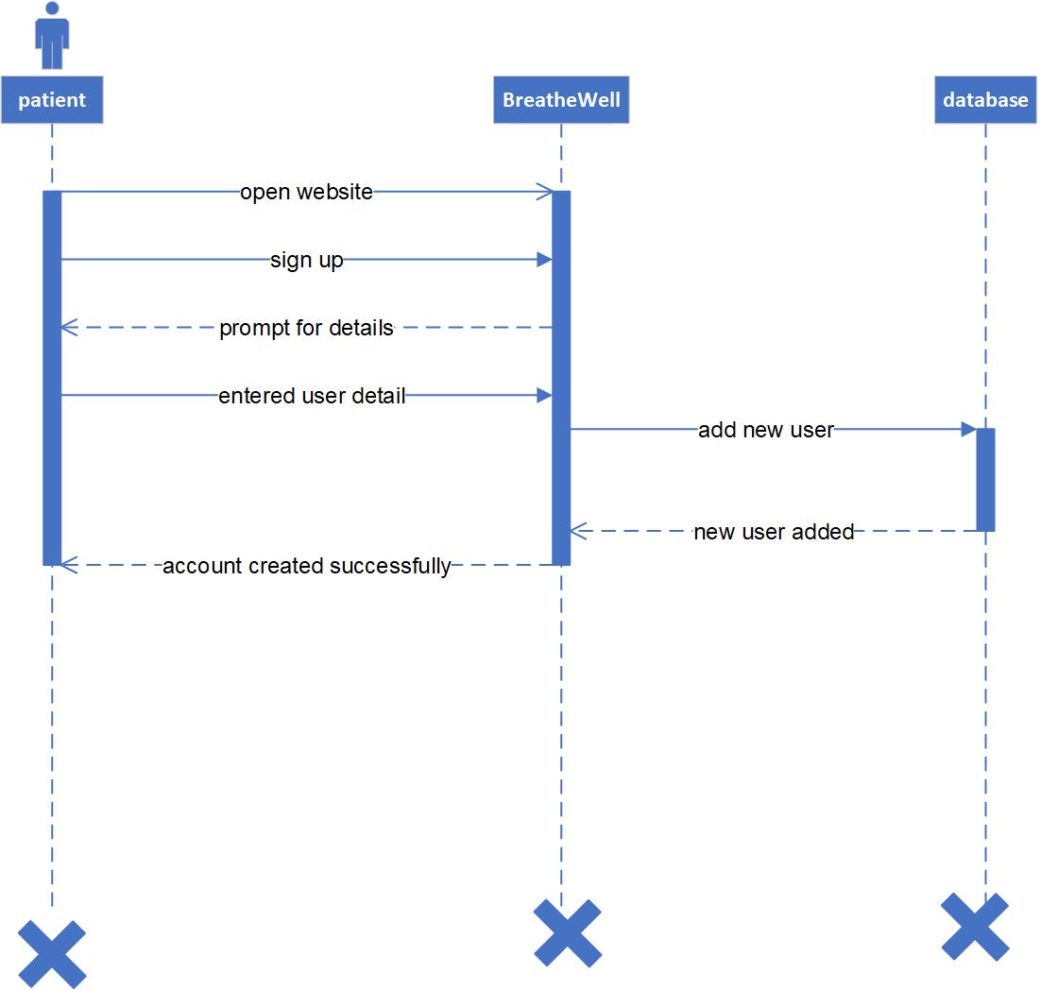
Figure ‎4.10 sequence diagram for account registration
4.4.2.2.7 Care plan
Figure 4.11 models the process to see the patient’s care plan
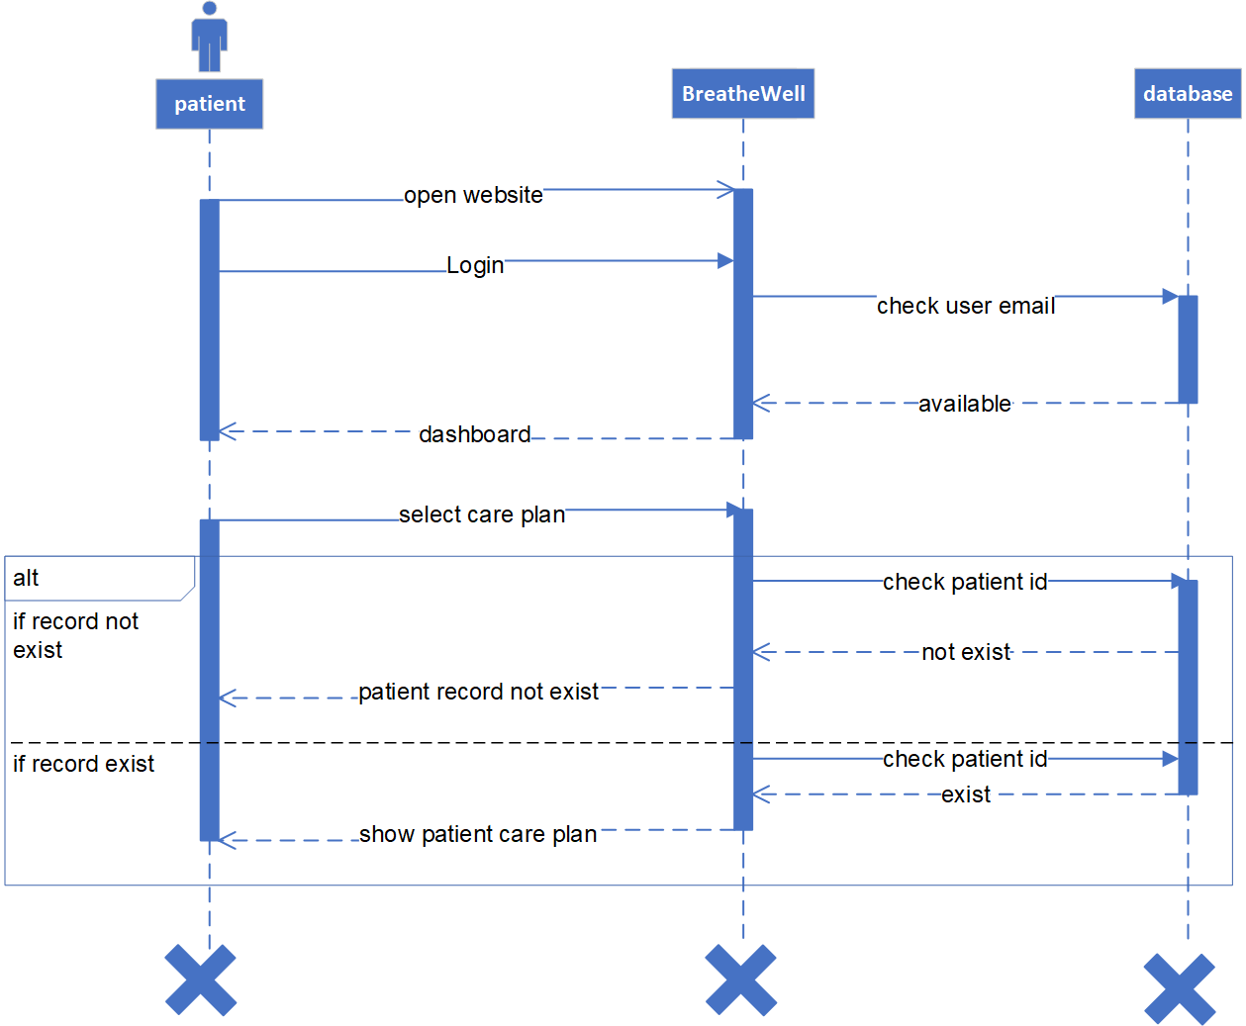
Figure ‎4.11 sequence diagram for care plan

4.4.2.2.8 Exercise Recommendation
Figure 4.12 models the process to see exercise recommendation
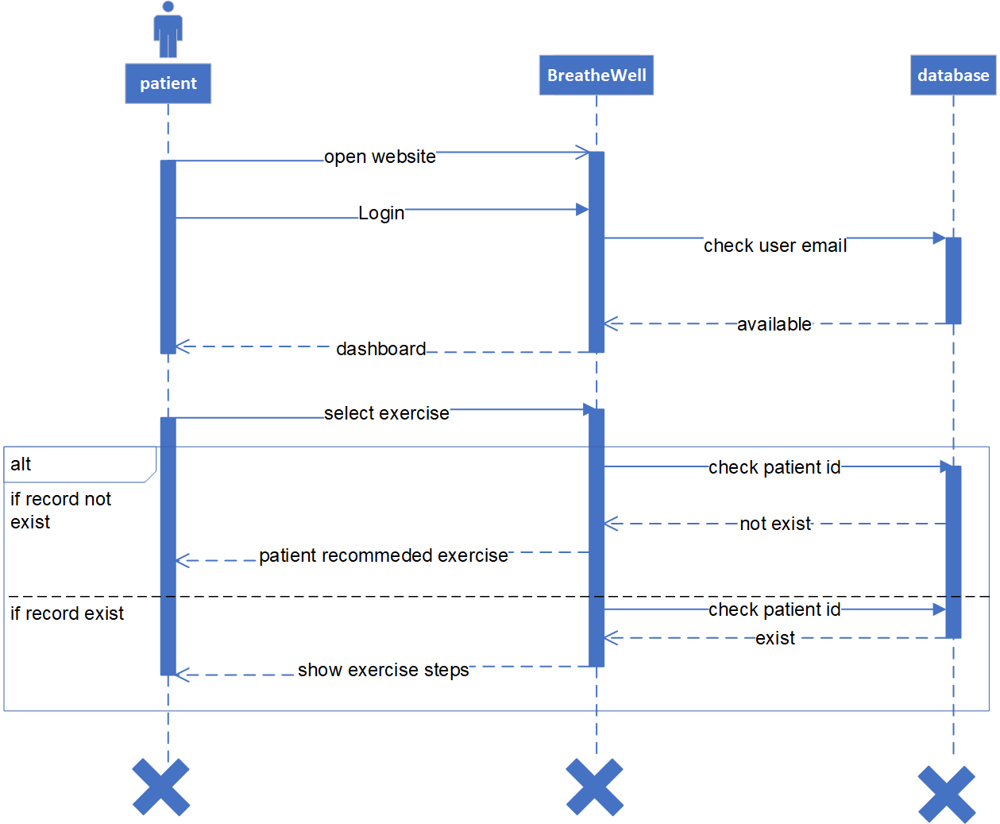
Figure ‎4.12 sequence diagram for exercise recommendation

4.4.2.2.9 Appointment Schedule
Figure 4.13 models the process to make a successful appointment.
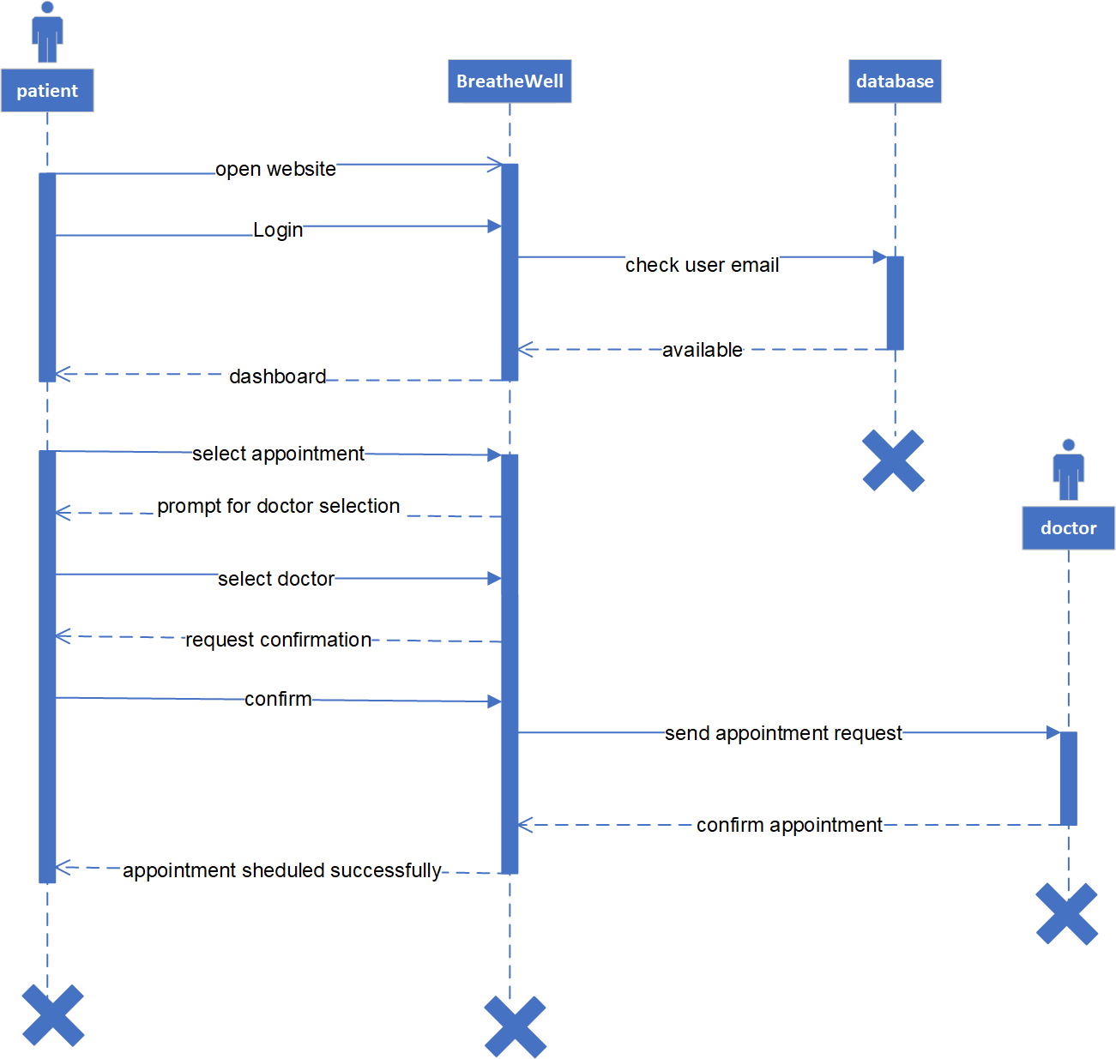
Figure ‎4.13 sequence diagram for appointment schedule

4.4.2.2.10 See Appointment
Figure 4.14 models the process of checking the appointment requests for a doctor.
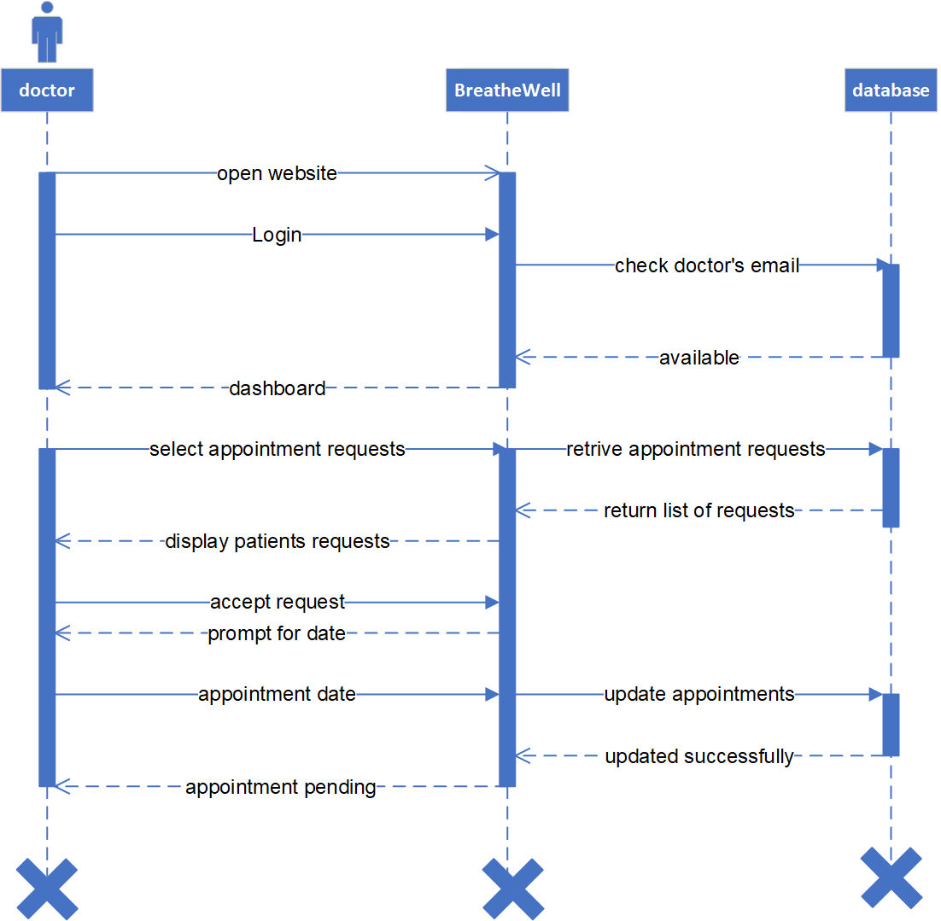
Figure ‎4.14 sequence diagram for see appointment request for doctor

4.4.3 Development View
This view describes the actual software implementation structure, focusing on the software organization, modules, sub-systems, and deployment strategy for developers.
4.4.3.1 Component Diagram for BreatheWell System.
The diagram illustrates how the major software components are structured, linked, and depend on each other to deliver the system's functionality. The system is divided into four main physical components: the Client Application, the API, the Logic Server, the AI/ML Service, and the Data Storage Components. Figure 4.15 shows the component diagram for our system
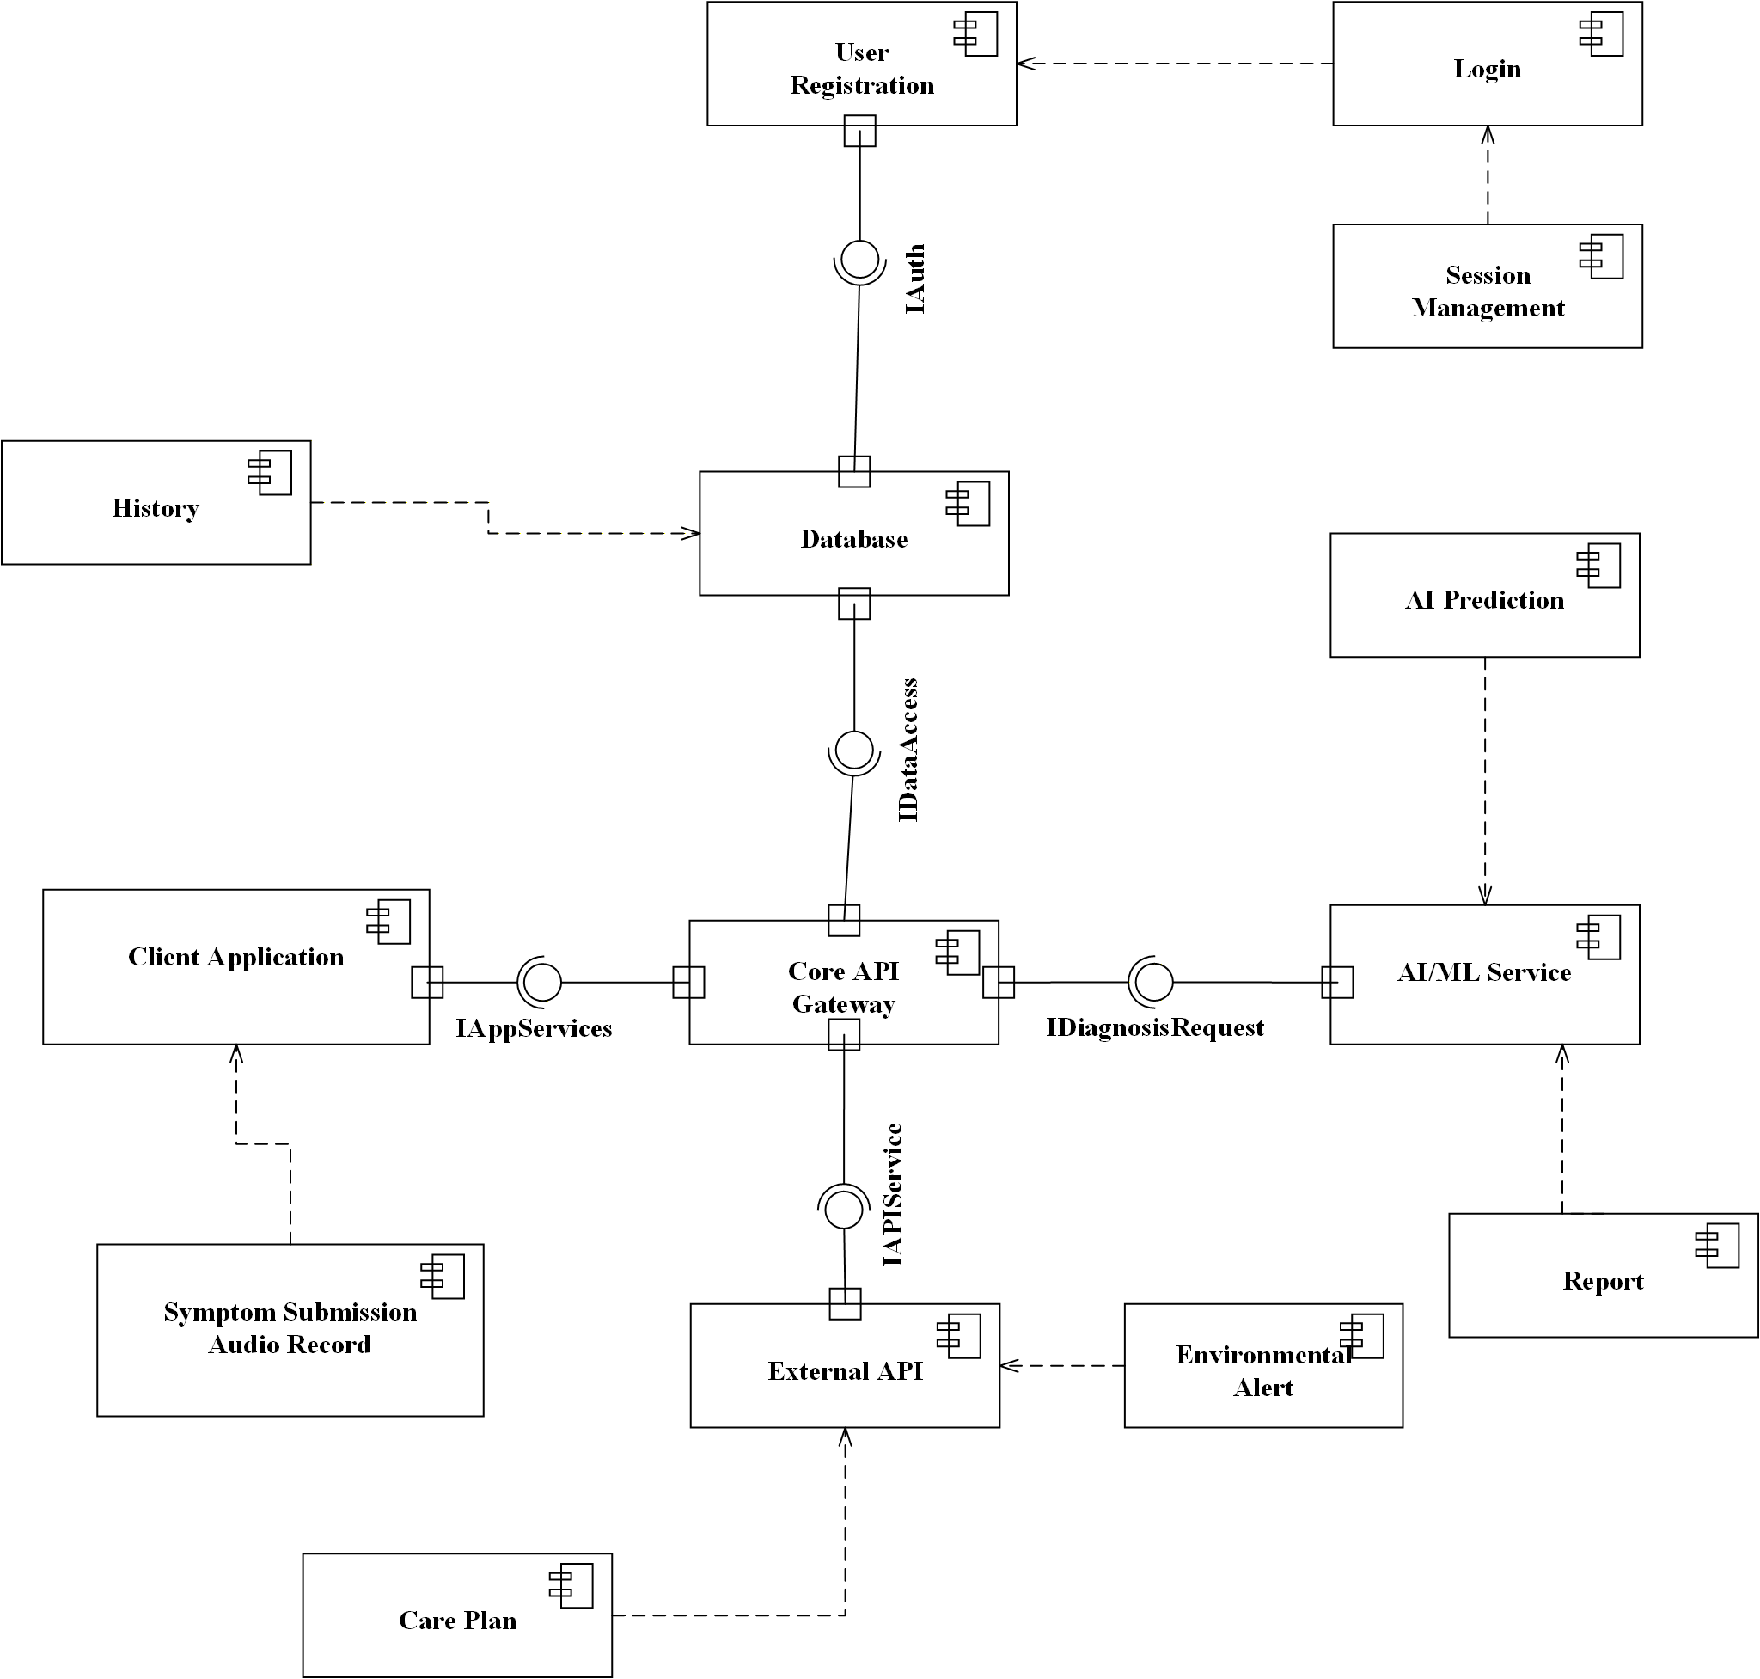
Figure ‎4.15 Component Diagram for BreatheWell System

4.4.4 Physical View
The Physical View of the BreatheWell system illustrates how the software components are deployed across various hardware nodes and cloud environments. It represents the system’s runtime configuration, highlighting the physical distribution of software artifacts, their hosting infrastructure, and inter-node communication.

4.4.4.1 Deployment Diagram
- The Deployment Diagram illustrates the run-time environment by detailing the nodes (hardware/virtual servers) and the artifacts (software components) deployed within them, connected by their communication pathways. Figure 4.16 shows the dyployment diagram of our system.
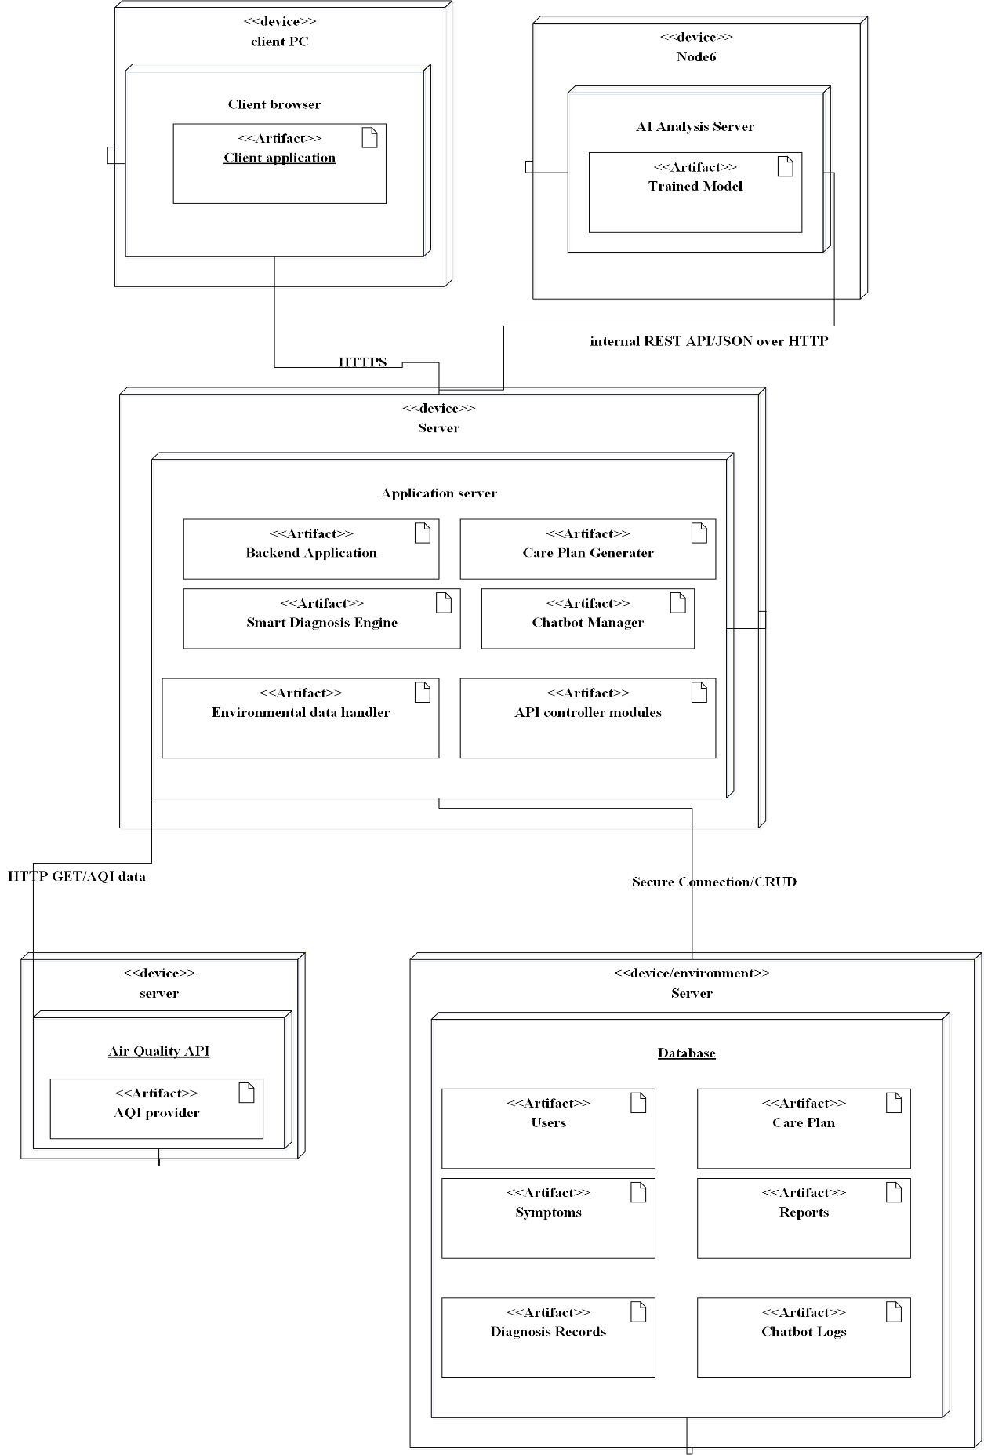
Figure ‎4.16 Deployment Diagram

4.4.5 Scenario View (+1 View)
This view, often represented by Use Case Diagrams and Sequence Diagrams, describes the interactions between the system components to fulfill a requirement. It validates the architectural design against the requirements.

4.5 App Design
The user interface (UI) for the BreatheWell system was developed with a strong focus on calmness, clarity, and trust, which are paramount for a health monitoring application. The design philosophy centers on making complex AI analysis feel approachable and easy for the user.
Design Theme and Aesthetic
The application employs a clean, modern, and health-centric aesthetic.
- Color Palette: Dominated by a crisp white background for optimal readability, complemented by soothing teal and turquoise accents (as seen in the logo and feature icons). This palette evokes feelings of tranquility, freshness, and clinical trust.
- Typography: A legible, clean sans-serif font is used to ensure all medical and tracking information is easily digestible.
- Imagery: The use of clear, modern illustrations (like the one showing lung health) immediately communicates the app's function while maintaining a friendly, non-intimidating tone.
Key UX/UI Decisions.
The visual elements are structured for immediate comprehension:
- Clear Value Proposition: The headline, "AI-powered lung health monitor coughs, track symptoms, get care," is prominently placed (as highlighted in your design) to instantly inform the user of the app's core services.
- Feature Accessibility: The main features (Audio analysis, Symptom tracker, Environmental alerts, Doctor connect) are presented as distinct, easy-to-read cards. This card-based layout makes complex services scannable and accessible.
- Minimalist Navigation: The top navigation (Home, About Us, How to use, Login) is kept minimal to reduce visual clutter and focus the user on the primary monitoring functions.
The following screens provide a detailed look at the interface, demonstrating how these design principles translate into a functional and effective user experience.

Figure 4.17 shows the landing page.
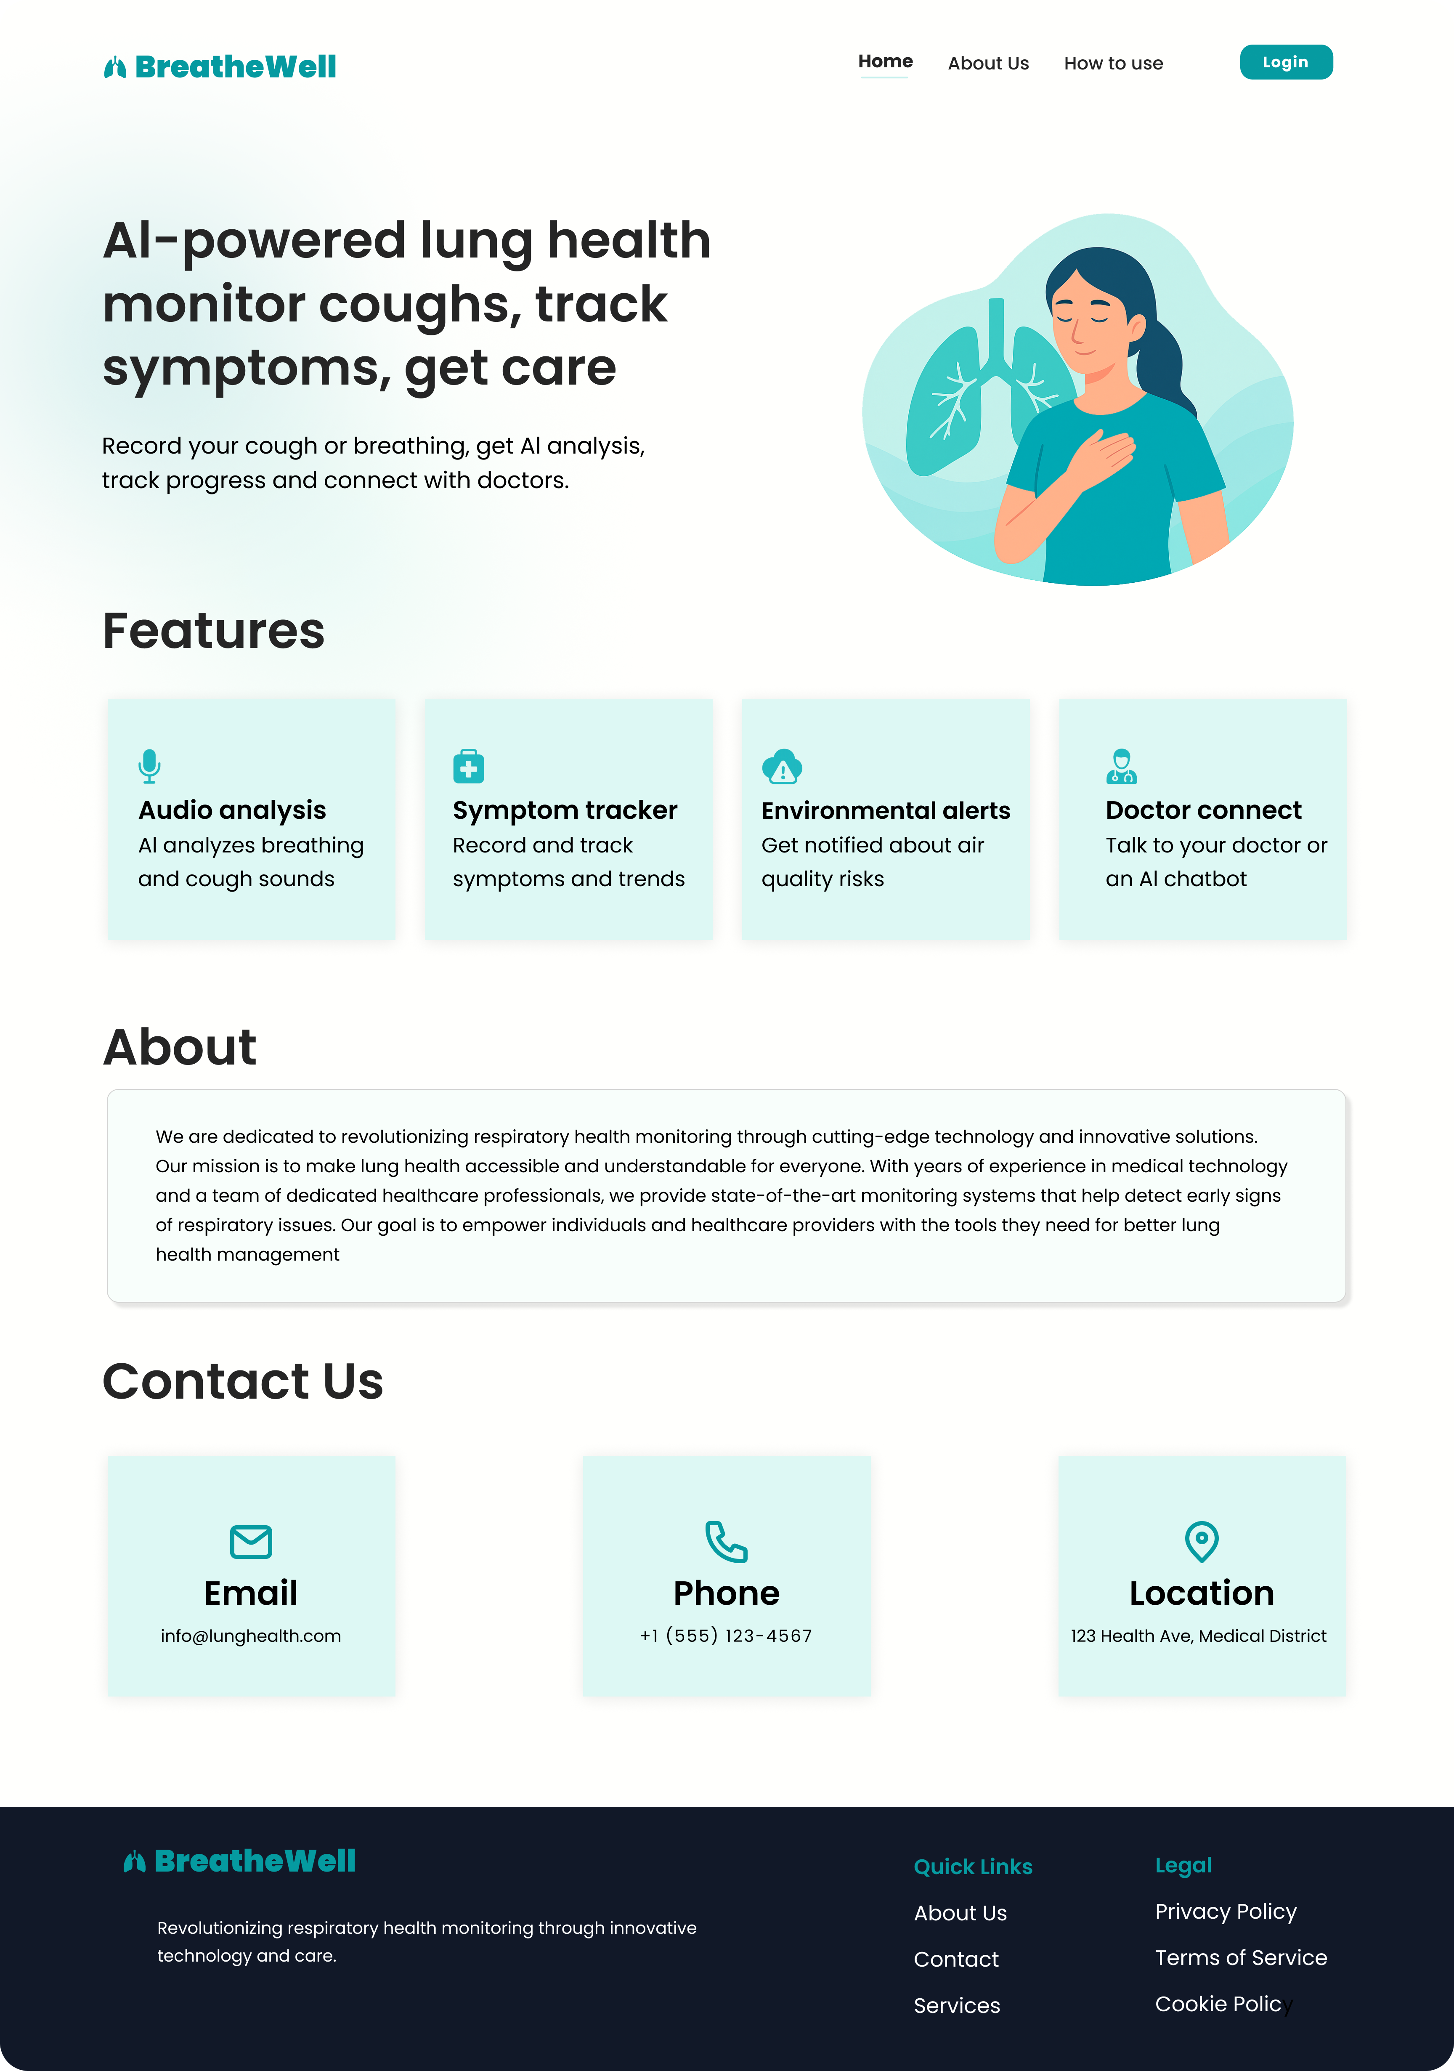
Figure ‎4.17 landing page
Figure 4.18 shows the login page.
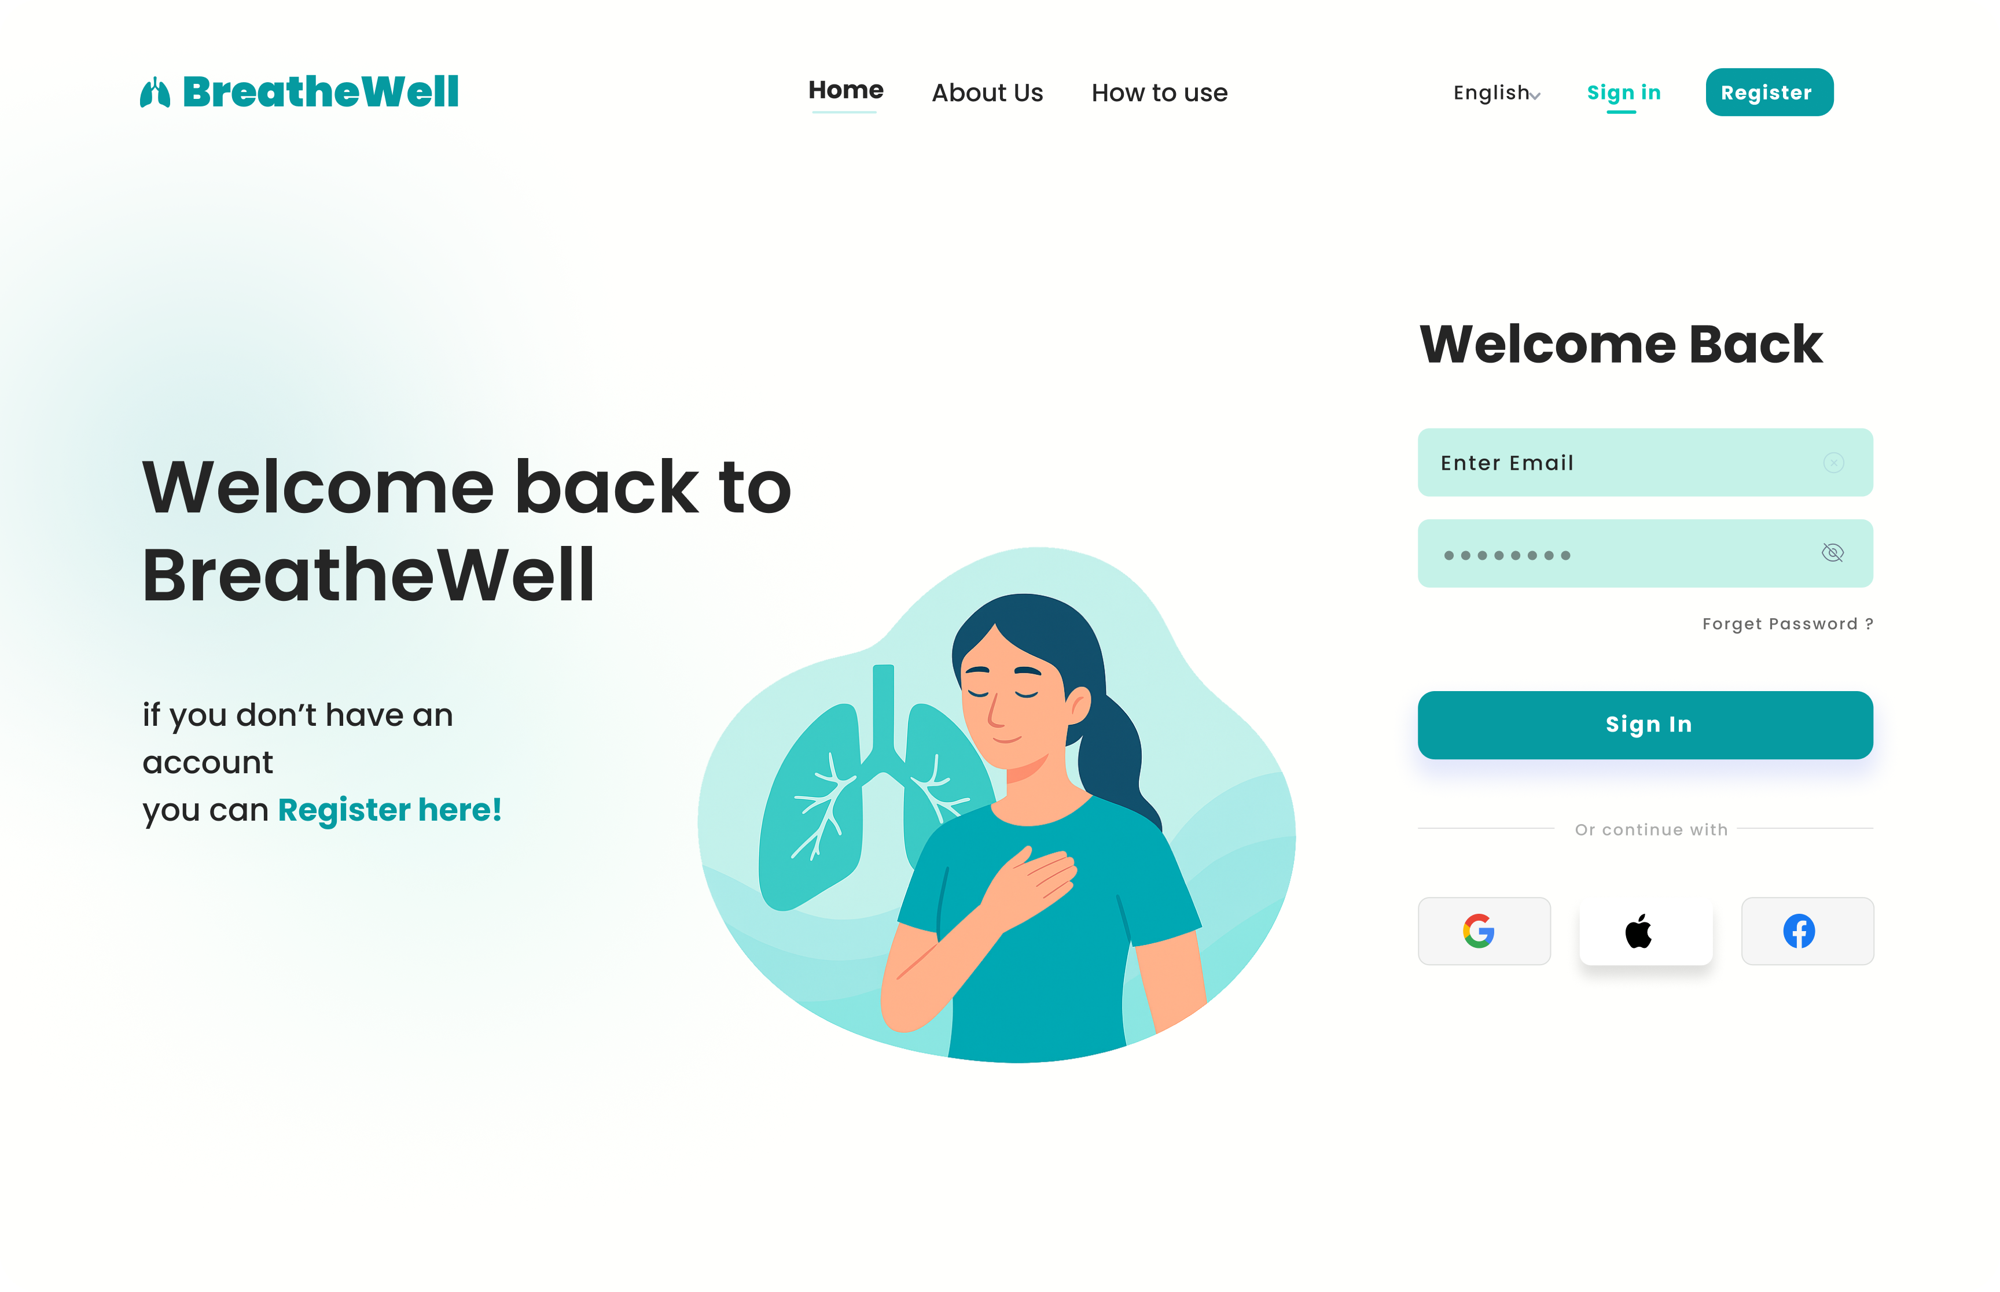
Figure ‎4.18 login page
Figure 4.19 shows the registration page.
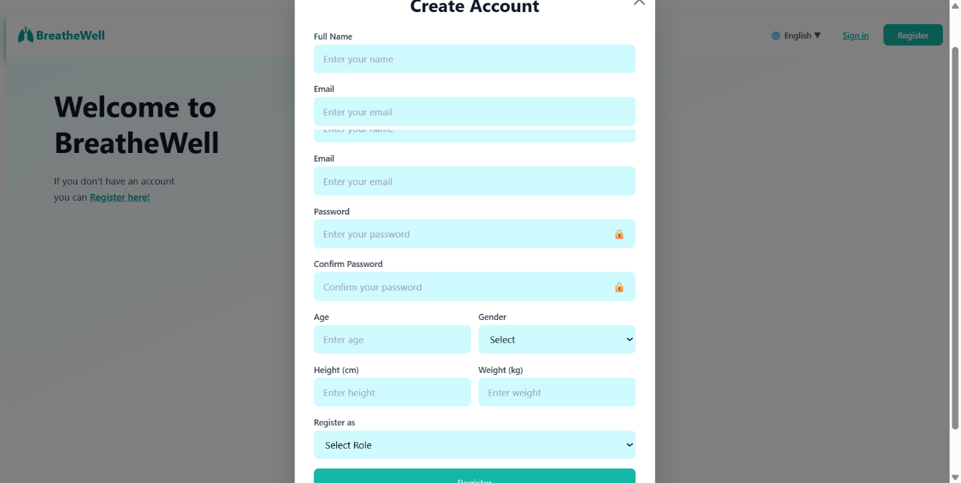
Figure ‎4.19 registration page
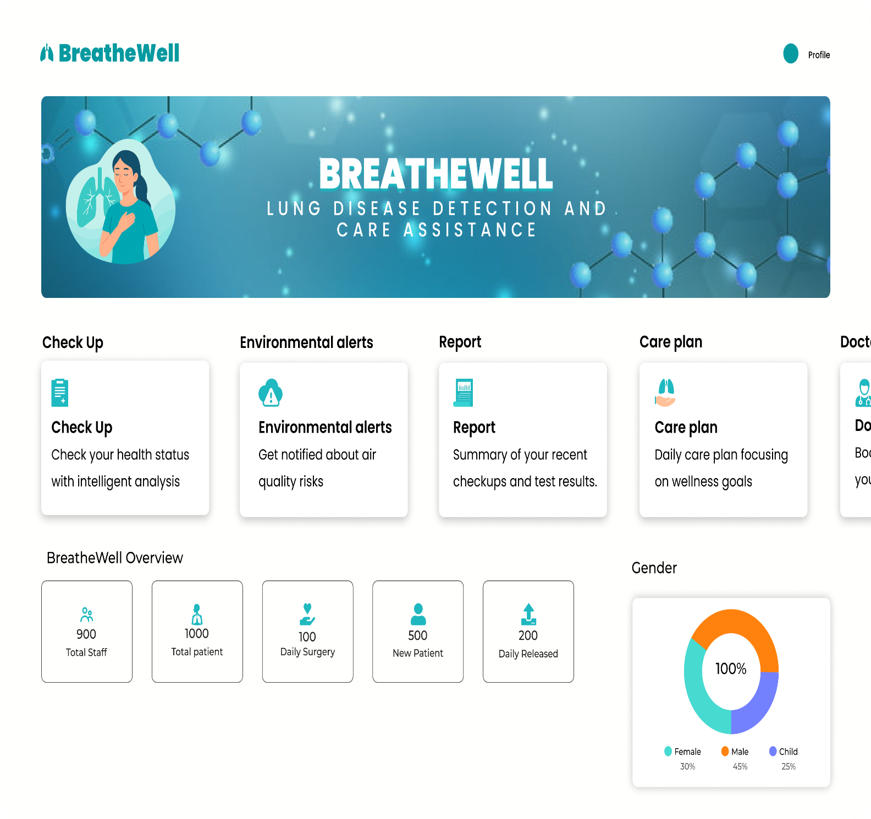
Figure 4.20 shows the dashboard page.

Figure ‎4.20 dashboard page

Figure 4.21 shows the symptom submission page.
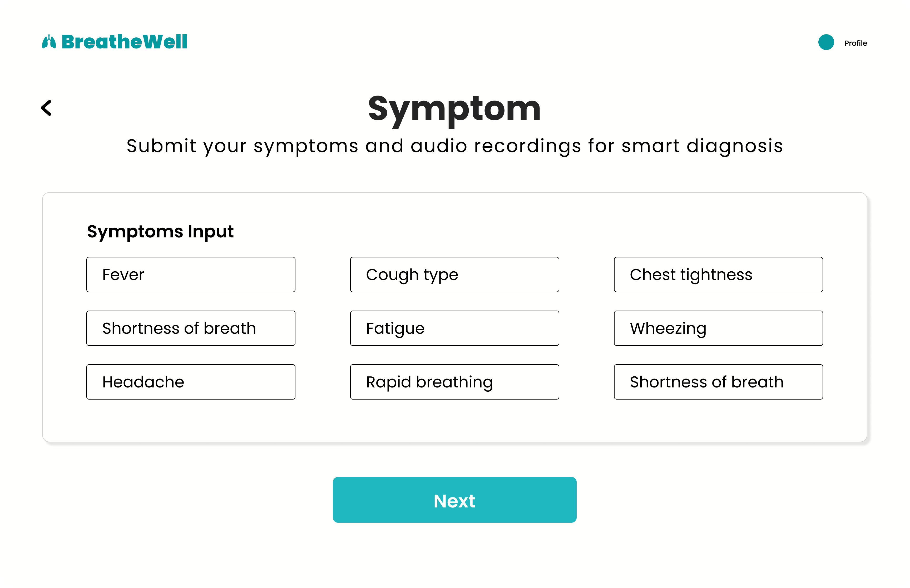
Figure ‎4.21 symptom submission page
Figure 4.22 shows the cough recording page.
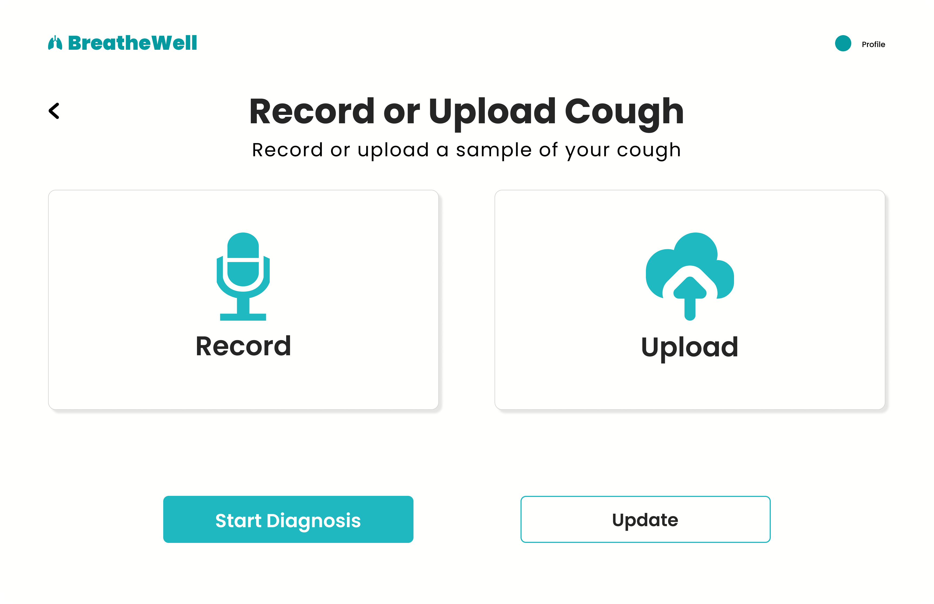
Figure ‎4.22 cough recording page
Figure 4.23 shows the report page.
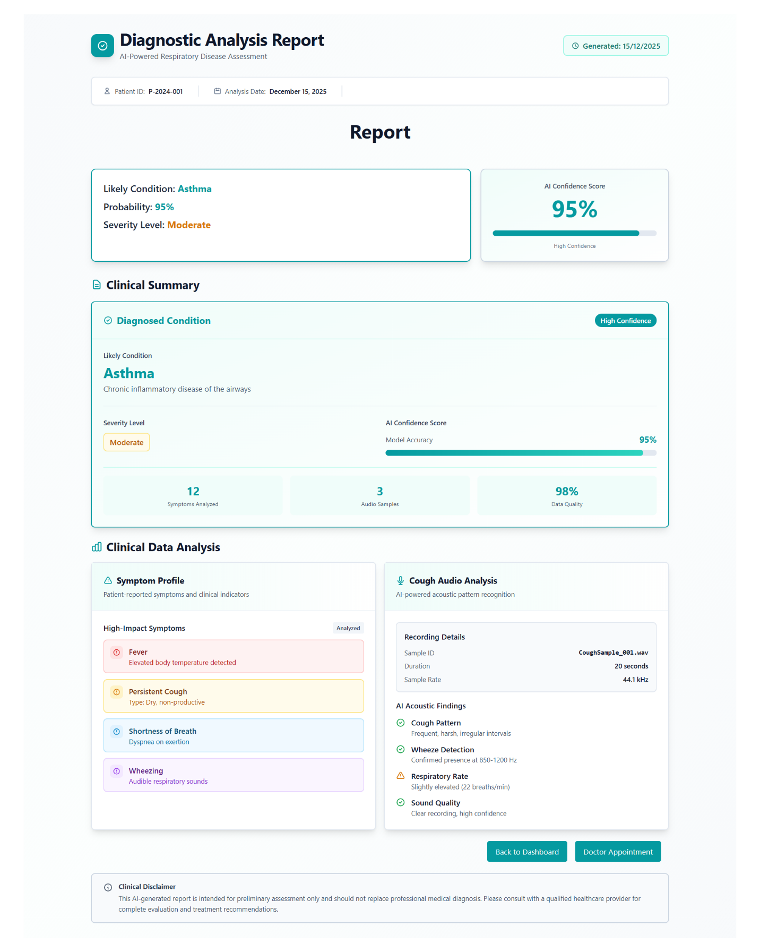
Figure ‎4.23 report page
Figure 4.24 shows the environmental alert page.
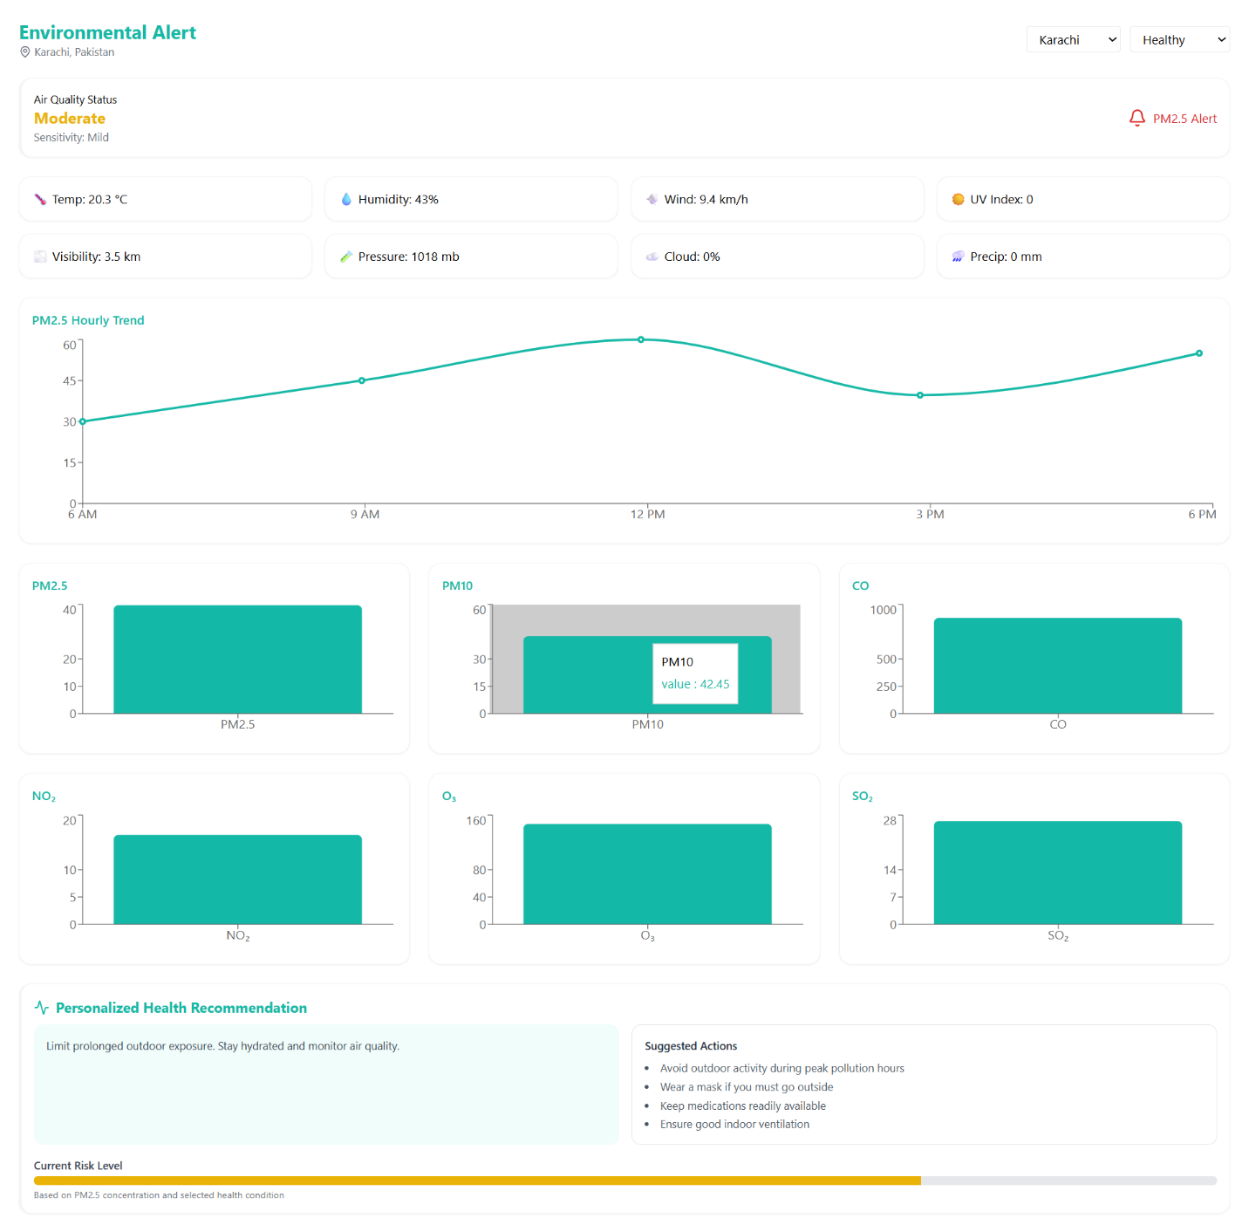
Figure ‎4.24 environmental alert page

Figure 4.25 shows the care plan page.
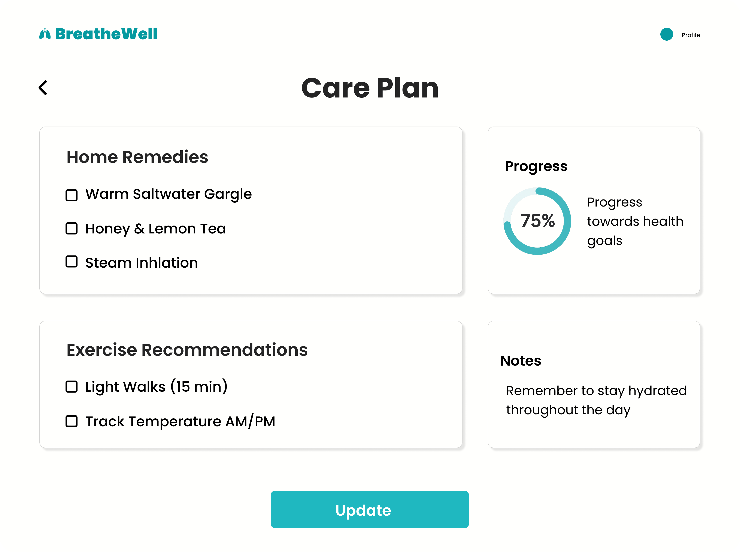
Figure ‎4.25 care plan page
Figure 4.26 shows the doctor list page.
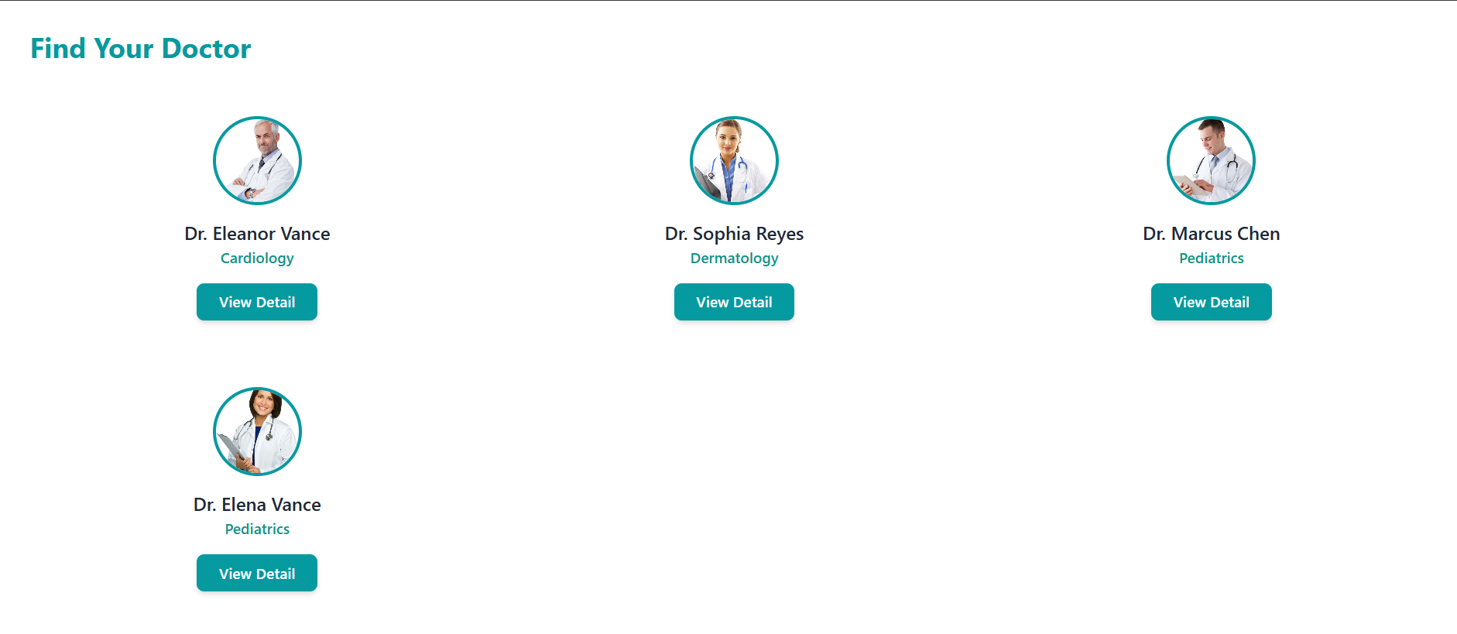
Figure ‎4.26 doctor list page
Figure 4.27 shows the doctor profile page.
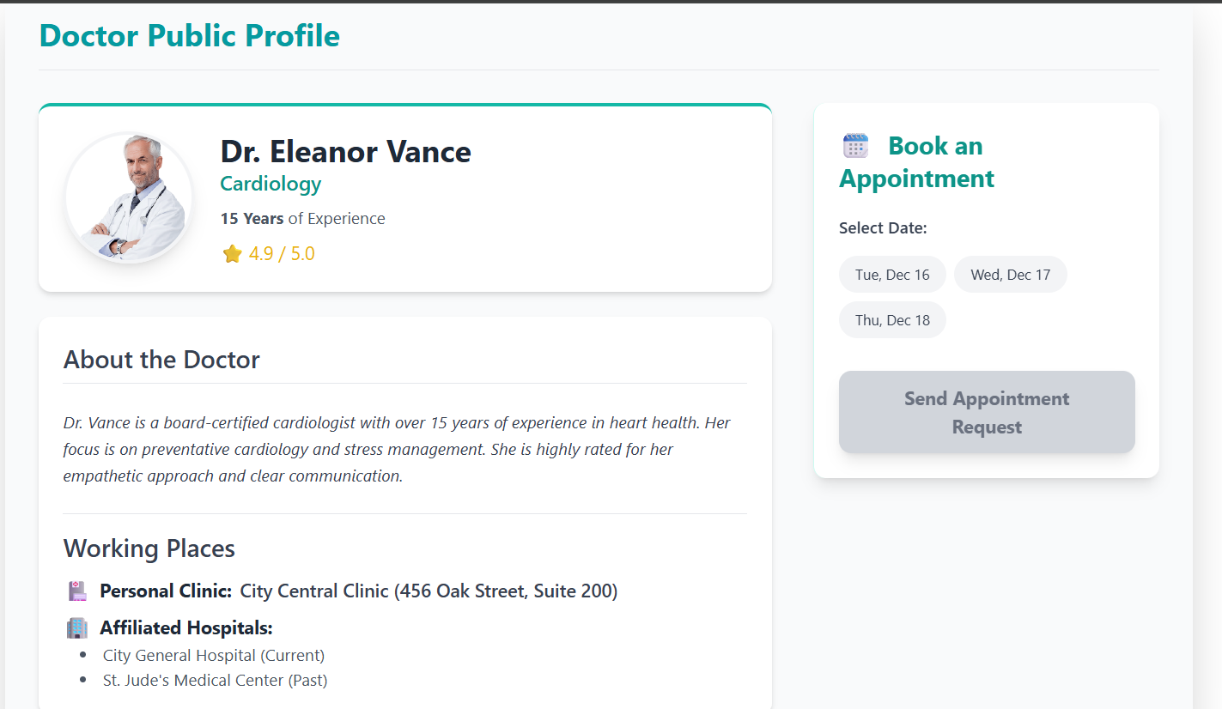
Figure ‎4.27 doctor profile page
Figure 4.28 shows the user profile page.
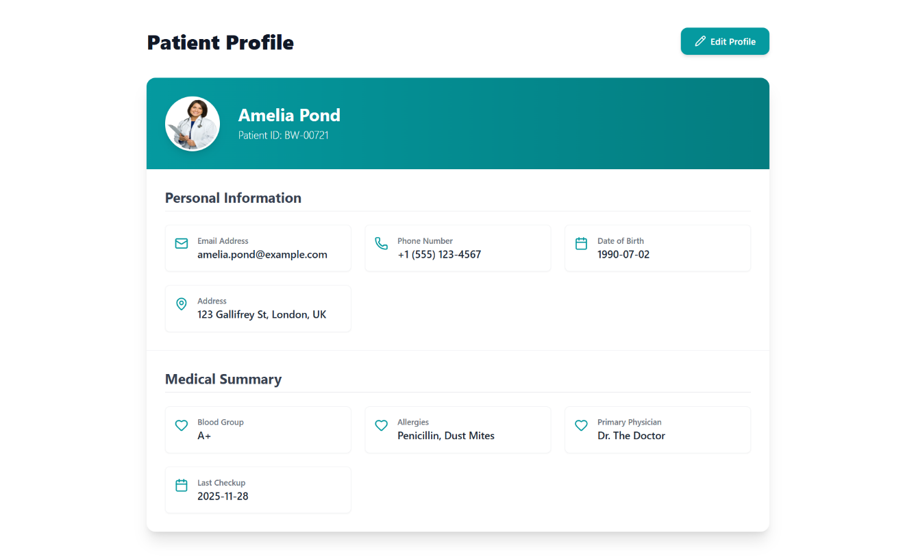
Figure ‎4.28 user profile page
Figure 4.29 shows the user edit profile page.
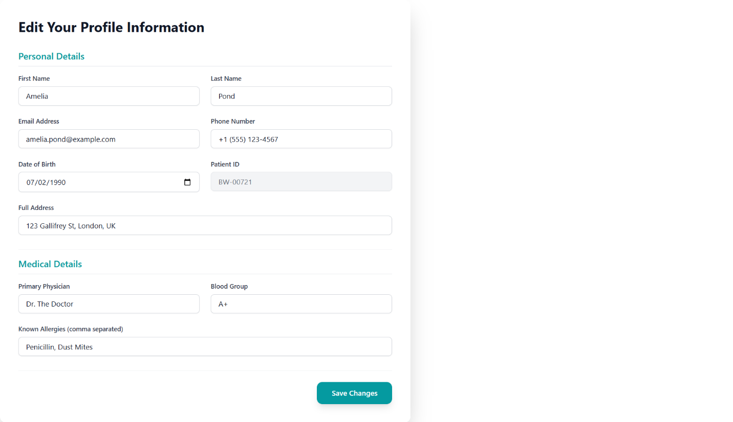
Figure ‎4.29 edit profile page
Figure 4.30 shows the setting page.
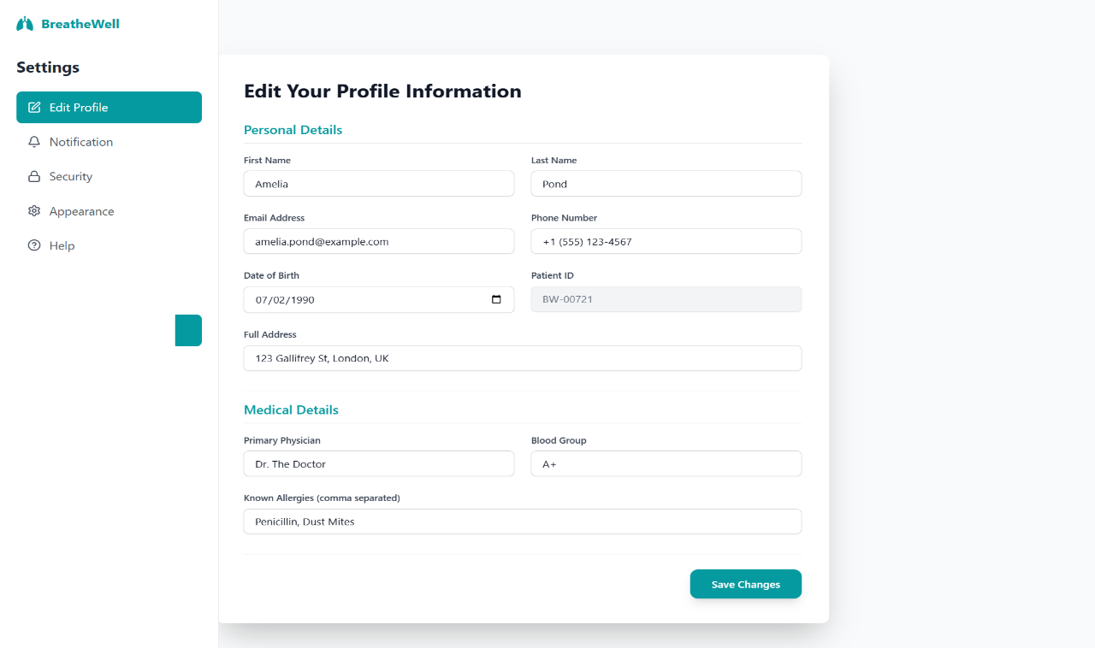
Figure ‎4.30 setting page

4.6 Summary
Chapter 4 provided the comprehensive System Modeling and Design for the BreatheWell application. The Three-Tier Architecture was established to ensure scalability and maintainability, separating the Presentation, Logic, and Data tiers. The importance of an intuitive Interface Design was highlighted, focusing on clarity and accessibility. Finally, the 4+1 View Model was used to structure the technical documentation, providing the necessary Logical, Process, Development, and Physical Views to guide the implementation phase effectively. The next chapter will focus on the detailed implementation and coding of these designed components.

References

[1] | W. W. M. K. H. Labaki,, "Chronic respiratory diseases: a global view," vol. 8.6, pp. 531-533, 2020.
[2] | H. A. E. Holland,, "How to adapt the pulmonary rehabilitation programme to patients with chronic respiratory disease other than COPD," European Respiratory, vol. 22., 2013.
[3] | (. Ada Health GmbH, "Ada Health: About Us," [Online]. Available: https://about.ada.com/. [Accessed 07 December 2025].
[4] | . I. AsthmaMD,, "AsthmaMD: About," 2010. [Online]. Available: https://www.asthmamd.org/about/. [Accessed 07 December 2025].
[5] | U. News, "UQ startup acquired by Pfizer.," The University of Queensland, 27 September 2022. [Online]. Available: https://news.uq.edu.au/2022-09-27-uq-startup-acquired-pfizer. [Accessed 07 December 2025].
[6] | Hyfe Inc. (n.d.)., "Hyfe: Detect & Quantify Cough," [Online]. Available: https://www.hyfe.com/. [Accessed 07 December 2025].

